 |  |  | UNITED STATES SECURITIES AND EXCHANGE COMMISSION
 |  |  | Washington, D.C. 20549
 |  |  | FORM |  |  | 8-K
 |  |  | CURRENT REPORT
 |  |  | Pursuant to Section 13 or 15(d) of the Securities Exchange Act of 1934
 |  |  | August 4, 2026
 |  |  | Date of Report (Date of earliest event reported)
Commission  File Number |  |  |  |  |  | Name of Registrant; State or Other Jurisdiction of Incorporation; Address of Principal Executive Offices; and Telephone Number |  |  |  |  |  | IRS Employer Identification Number
001-41137 |  |  |  |  |  | CONSTELLATION ENERGY CORPORATION |  |  |  |  |  | 87-1210716
(a Pennsylvania corporation)
1310 Point Street
Baltimore, Maryland 21231-3380
(833) 883-0162
Check the appropriate box below if the Form 8-K filing is intended to simultaneously satisfy the filing obligation of the registrant under any of the following provisions:
☐ |  |  | Written communications pursuant to Rule 425 under the Securities Act (17 CFR 230.425)
☐ |  |  | Soliciting material pursuant to Rule 14a-12 under the Exchange Act (17 CFR 240.14a-12)
☐ |  |  | Pre-commencement communications pursuant to Rule 14d-2(b) under the Exchange Act (17 CFR 240.14d-2(b))
☐ |  |  | Pre-commencement communications pursuant to Rule 13e-4(c) under the Exchange Act (17 CFR 240.13e-4(c))
Securities registered pursuant to Section 12(b) of the Act:
Title of each class |  |  |  |  |  | Trading Symbol(s) |  |  |  |  |  | Name of each exchange on which registered
CONSTELLATION ENERGY CORPORATION:
Common Stock, without par value |  |  |  |  |  | CEG |  |  |  |  |  | The Nasdaq Stock Market LLC
Indicate by check mark whether the registrant is an emerging growth company as defined in Rule 405 of the Securities Act of 1933 (§230.405 of this chapter) or Rule 12b-2 of the Securities Exchange Act of 1934 (§240.12b-2 of this chapter). Emerging growth company ☐
If an emerging growth company, indicate by check mark if the registrant has elected not to use the extended transition period for complying with any new or revised financial accounting standards provided pursuant to Section 13(a) of the Exchange Act. ☐

Section 5 – Corporate Governance and Management
Item 5.02(b). Departure of Directors or Certain Officers; Election of Directors; Appointment of Certain Officers; Compensatory Arrangements of Certain Officers.

On August 4, 2026, Robert Lawless, Chair of the Board of Directors (the “Board”) of Constellation Energy Corporation (the “Company”), retired from the Board. In connection with the retirement of Mr. Lawless as Chair of the Board, the Board elected Joseph Dominguez, the Company’s President and Chief Executive Officer, to serve as Chair of the Board, effective August 4, 2026. As a result of Mr. Dominguez being named Chair of the Board, Charles Harrington, Chair of the Corporate Governance Committee of the Board, will also serve as Lead Independent Director of the Board. In addition to the standard compensation for directors disclosed in the Company’s proxy statement, Mr. Harrington will receive an annual cash retainer equal to $50,000 for his service as Lead Independent Director.

On August 4, 2026, the Board elected Roger Crandall as a director, effective August 5, 2026, to serve until the Company’s 2027 annual meeting of shareholders. The Board has not yet determined the committee(s) on which Mr. Crandall will be appointed to serve. Mr. Crandall will receive the standard compensation for directors as disclosed in the Company’s proxy statement.

A copy of the press release regarding the foregoing changes to the Board issued on August 5, 2026, is attached hereto as Exhibit 99.1 and incorporated herein by reference.

Section 9 - Financial Statements and Exhibits
Item 9.01. Financial Statements and Exhibits

(d) Exhibits.
Exhibit No. |  |  |  |  |  | Description
99.1 |  |  |  |  |  | Press Release
101 |  |  |  |  |  | Cover Page Interactive Data File - the cover page XBRL tags are embedded within the Inline XBRL document.
104 |  |  |  |  |  | The cover page from the Current Report on Form 8-K, formatted as Inline XBRL.

SIGNATURE

Pursuant to the requirements of the Securities Exchange Act of 1934, the registrant has duly caused this report to be signed on its behalf by the undersigned hereunto duly authorized.
CONSTELLATION ENERGY CORPORATION
/s/ Arden T. Phillips
Arden T. Phillips
Vice President, Deputy General Counsel and Corporate Secretary

August 5, 2026

EXHIBIT INDEX
Exhibit No. |  |  |  |  |  | Description
99.1 |  |  |  |  |  | Press Release
101 |  |  |  |  |  | Cover Page Interactive Data File - the cover page XBRL tags are embedded within the Inline XBRL document.
104 |  |  |  |  |  | The cover page from the Current Report on Form 8-K, formatted as Inline XBRL.


Contact: Dave Snyder Constellation Communications 667-218-7700 david.snyder@constellation.com FOR IMMEDIATE RELEASE Constellation Announces Board Chairman Transition and New Board Appointment BALTIMORE, Md. — (Aug. 5, 2026)— Constellation (Nasdaq: CEG) today announced that its Board of Directors has elected President and Chief Executive Officer Joe Dominguez to serve as Chairman of the Board, effective Aug. 4, 2026, and appointed Roger Crandall, Chairman, President and Chief Executive Officer of MassMutual, to the Board as an independent director, effective Aug. 5, 2026. Charles L. Harrington will serve as Lead Independent Director, reinforcing the company's strong governance framework and independent Board oversight. Crandall brings nearly four decades of leadership experience in financial services and has served as chief executive officer of MassMutual since 2010. MassMutual, a Fortune 100 company, is one of America’s largest mutual life insurance companies, serving more than four million customers with over $1 trillion in life insurance in force. Under Crandall’s leadership, the 175- year-old company has delivered strong long-term performance and exceptional value to its policyowners. He recently completed service as Chair of the Federal Reserve Bank of Boston and currently serves on several business, educational and nonprofit boards. Crandall earned an MBA from the Wharton School of the University of Pennsylvania and a bachelor's degree in economics from the University of Vermont. "Roger is an exceptional business leader with deep expertise in capital allocation, risk management, technology transformation and corporate governance," said Dominguez. "His perspective and experience will be invaluable as Constellation continues to execute its strategy and meet growing demand for reliable, carbon-free energy." "Constellation plays a critical role in powering economic growth and advancing a more reliable and sustainable energy future," said Crandall. "I look forward to working with the Board and leadership team to support the company's long-term success and value creation, all in service of building a better tomorrow for communities across the country." These appointments follow the resignation of Robert J. Lawless from the Board, effective Aug. 4, 2026. Lawless concludes a distinguished tenure spanning more than two decades of service to Constellation. He served on the board of legacy Constellation Energy Group from 2002 until its merger with Exelon in 2012, on the Exelon Board from 2012 to 2022, and as chairman of

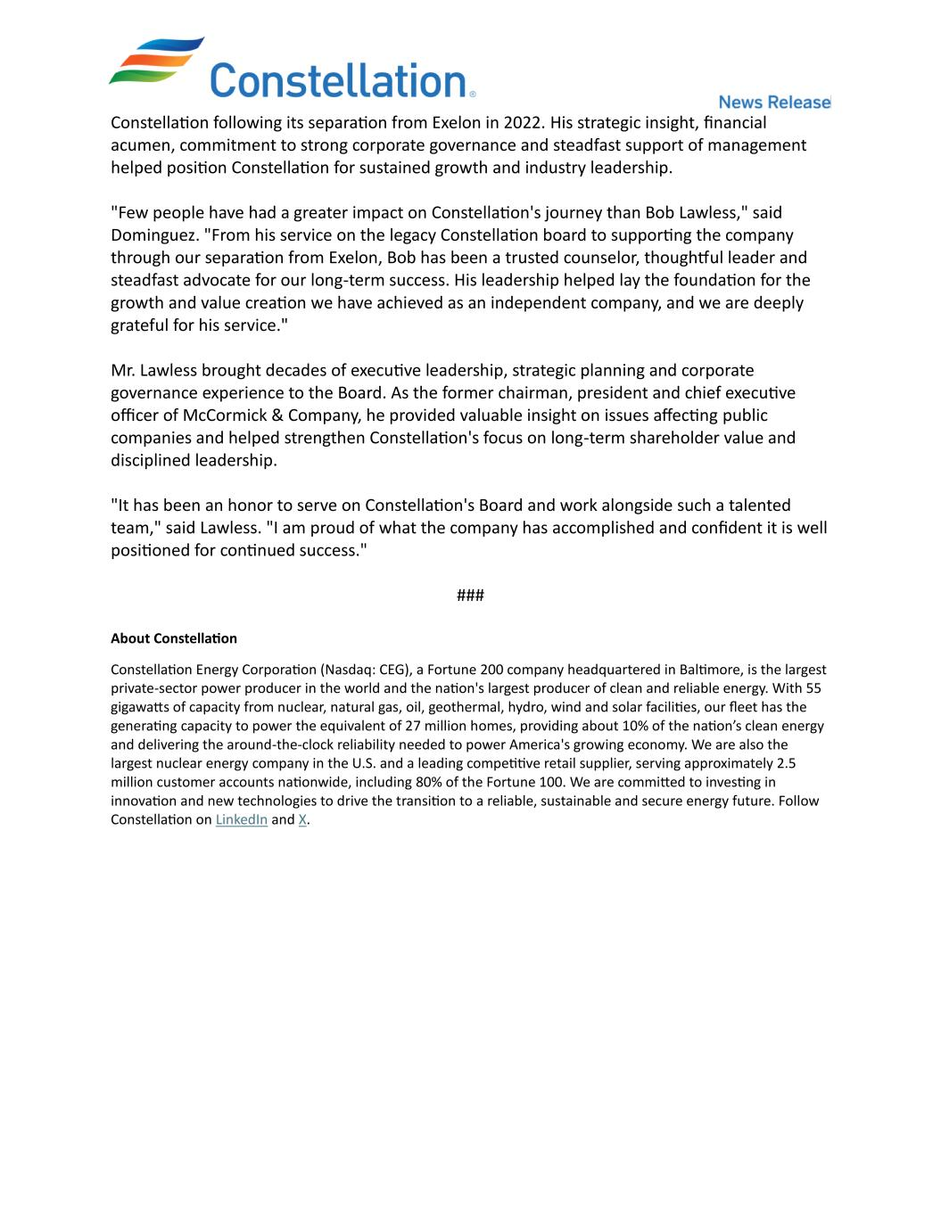
Constellation following its separation from Exelon in 2022. His strategic insight, financial acumen, commitment to strong corporate governance and steadfast support of management helped position Constellation for sustained growth and industry leadership. "Few people have had a greater impact on Constellation's journey than Bob Lawless," said Dominguez. "From his service on the legacy Constellation board to supporting the company through our separation from Exelon, Bob has been a trusted counselor, thoughtful leader and steadfast advocate for our long-term success. His leadership helped lay the foundation for the growth and value creation we have achieved as an independent company, and we are deeply grateful for his service." Mr. Lawless brought decades of executive leadership, strategic planning and corporate governance experience to the Board. As the former chairman, president and chief executive officer of McCormick & Company, he provided valuable insight on issues affecting public companies and helped strengthen Constellation's focus on long-term shareholder value and disciplined leadership. "It has been an honor to serve on Constellation's Board and work alongside such a talented team," said Lawless. "I am proud of what the company has accomplished and confident it is well positioned for continued success." ### About Constellation Constellation Energy Corporation (Nasdaq: CEG), a Fortune 200 company headquartered in Baltimore, is the largest private-sector power producer in the world and the nation's largest producer of clean and reliable energy. With 55 gigawatts of capacity from nuclear, natural gas, oil, geothermal, hydro, wind and solar facilities, our fleet has the generating capacity to power the equivalent of 27 million homes, providing about 10% of the nation’s clean energy and delivering the around-the-clock reliability needed to power America's growing economy. We are also the largest nuclear energy company in the U.S. and a leading competitive retail supplier, serving approximately 2.5 million customer accounts nationwide, including 80% of the Fortune 100. We are committed to investing in innovation and new technologies to drive the transition to a reliable, sustainable and secure energy future. Follow Constellation on LinkedIn and X.

