 |  |  | UNITED STATES SECURITIES AND EXCHANGE COMMISSION
 |  |  | Washington, D.C. 20549
 |  |  | FORM |  |  | 8-K
 |  |  | CURRENT REPORT
 |  |  | Pursuant to Section 13 or 15(d) of the Securities Exchange Act of 1934
 |  |  | March 31, 2026
 |  |  | Date of Report (Date of earliest event reported)
Commission  File Number |  |  |  |  |  | Name of Registrant; State or Other Jurisdiction of Incorporation; Address of Principal Executive Offices; and Telephone Number |  |  |  |  |  | IRS Employer Identification Number
001-41137 |  |  |  |  |  | CONSTELLATION ENERGY CORPORATION |  |  |  |  |  | 87-1210716
(a Pennsylvania corporation)
1310 Point Street
Baltimore, Maryland 21231-3380
(833) 883-0162
333-85496 |  |  |  |  |  | CONSTELLATION ENERGY GENERATION, LLC |  |  |  |  |  | 23-3064219
(a Pennsylvania limited liability company)
200 Energy Way
Kennett Square, Pennsylvania 19348-2473
(833) 883-0162
Check the appropriate box below if the Form 8-K filing is intended to simultaneously satisfy the filing obligation of the registrant under any of the following provisions:
☐ |  |  | Written communications pursuant to Rule 425 under the Securities Act (17 CFR 230.425)
☐ |  |  | Soliciting material pursuant to Rule 14a-12 under the Exchange Act (17 CFR 240.14a-12)
☐ |  |  | Pre-commencement communications pursuant to Rule 14d-2(b) under the Exchange Act (17 CFR 240.14d-2(b))
☐ |  |  | Pre-commencement communications pursuant to Rule 13e-4(c) under the Exchange Act (17 CFR 240.13e-4(c))
Securities registered pursuant to Section 12(b) of the Act:
Title of each class |  |  |  |  |  | Trading Symbol(s) |  |  |  |  |  | Name of each exchange on which registered
CONSTELLATION ENERGY CORPORATION:
Common Stock, without par value |  |  |  |  |  | CEG |  |  |  |  |  | The Nasdaq Stock Market LLC
Indicate by check mark whether any of the registrants are emerging growth companies as defined in Rule 405 of the Securities Act of 1933 (§230.405 of this chapter) or Rule 12b-2 of the Securities Exchange Act of 1934 (§240.12b-2 of this chapter).

Emerging growth company ☐
If an emerging growth company, indicate by check mark if any of the registrants have elected not to use the extended transition period for complying with any new or revised financial accounting standards provided pursuant to Section 13(a) of the Exchange Act. ☐

Section 7 - Regulation FD
Item 7.01. Regulation FD Disclosure

Constellation has scheduled a conference call for 8:00 AM ET on March 31, 2026 to discuss our 2026 Business and Earnings Outlook. To access the call by phone, please follow the registration link available on the Investor Relations page of Constellation’s website: https://investors.constellationenergy.com. The call will also be webcast and archived on the Investor Relations page of Constellation’s website. Media representatives are invited to participate on a listen-only basis. The materials being presented on the call are attached as Exhibit 99.1, are incorporated by reference and are being furnished to, but not filed with, the SEC.

Section 9 – Financial Statements and Exhibits
Item 9.01. Financial Statements and Exhibits

(d) Exhibits.
Exhibit No. |  |  |  |  |  | Description
99.1 |  |  |  |  |  | 2026 Business and Earnings Outlook presentation
101 |  |  |  |  |  | Cover Page Interactive Data File - the cover page XBRL tags are embedded within the Inline XBRL document.
104 |  |  |  |  |  | The cover page from this Current Report on Form 8-K, formatted as Inline XBRL.

* * * * *
This combined Current Report on Form 8-K is being furnished separately by Constellation Energy Corporation and Constellation Energy Generation, LLC (collectively, the “Registrants”). Information contained herein relating to any individual Registrant has been furnished by such Registrant on its own behalf. Neither Registrant makes any representation as to information relating to the other Registrant.

This Current Report on Form 8-K contains certain forward-looking statements within the meaning of the Private Securities Litigation Reform Act of 1995 that are subject to risks and uncertainties. Words such as “could,” “may,” “expects,” “anticipates,” “will,” “targets,” “goals,” “projects,” “intends,” “plans,” “believes,” “seeks,” “estimates,” “predicts,” and variations on such words, and similar expressions that reflect the Registrants’ current views with respect to future events and operational, economic, and financial performance, are intended to identify such forward-looking statements. These forward-looking statements include, but are not limited to, statements regarding the acquisition of Calpine Corporation, the pro forma combined company and its operations, strategies and plans, enhancements to investment-grade credit profile, synergies, opportunities and anticipated future performance and capital structure, and expected accretion to earnings per share and free cash flow. Information adjusted for the transaction should not be considered a forecast of future results. Although the Registrants believe these forward-looking statements are reasonable, statements made regarding future results are not guarantees of future performance and are subject to numerous assumptions, uncertainties and risks that are difficult to predict. Forward-looking statements are based on current expectations, estimates and assumptions that involve a number of risks and uncertainties that could cause actual results to differ materially from those projected.

The factors that could cause actual results to differ materially from the forward-looking statements made by the Registrants include those factors discussed herein, as well as the items discussed in (1) the Registrants' 2025 Annual Report on Form 10-K in (a) Part I, ITEM 1A. Risk Factors, (b) Part II, ITEM 7. Management’s Discussion and Analysis of Financial Condition and Results of Operations, and (c) Part II, ITEM 8. Financial Statements and Supplementary Data: Note 18, Commitments and Contingencies; and (2) other factors discussed in filings with the SEC by the Registrants.

Investors are cautioned not to place undue reliance on these forward-looking statements, whether written or oral, which apply only as of the date of this Current Report on Form 8-K. Neither Registrant undertakes any obligation to publicly release any revision to its forward-looking statements to reflect events or circumstances after the date of this Current Report on Form 8-K.

SIGNATURES

Pursuant to the requirements of the Securities Exchange Act of 1934, each Registrant has duly caused this report to be signed on its behalf by the undersigned hereunto duly authorized.
CONSTELLATION ENERGY CORPORATION
/s/ Shane P. Smith
Shane P. Smith
Executive Vice President and Chief Financial Officer
CONSTELLATION ENERGY GENERATION, LLC
/s/ Shane P. Smith
Shane P. Smith
Executive Vice President and Chief Financial Officer

March 31, 2026

EXHIBIT INDEX
Exhibit No. |  |  |  |  |  | Description
99.1 |  |  |  |  |  | 2026 Business and Earnings Outlook presentation
101 |  |  |  |  |  | Cover Page Interactive Data File - the cover page XBRL tags are embedded within the Inline XBRL document.
104 |  |  |  |  |  | The cover page from this Current Report on Form 8-K, formatted as Inline XBRL.
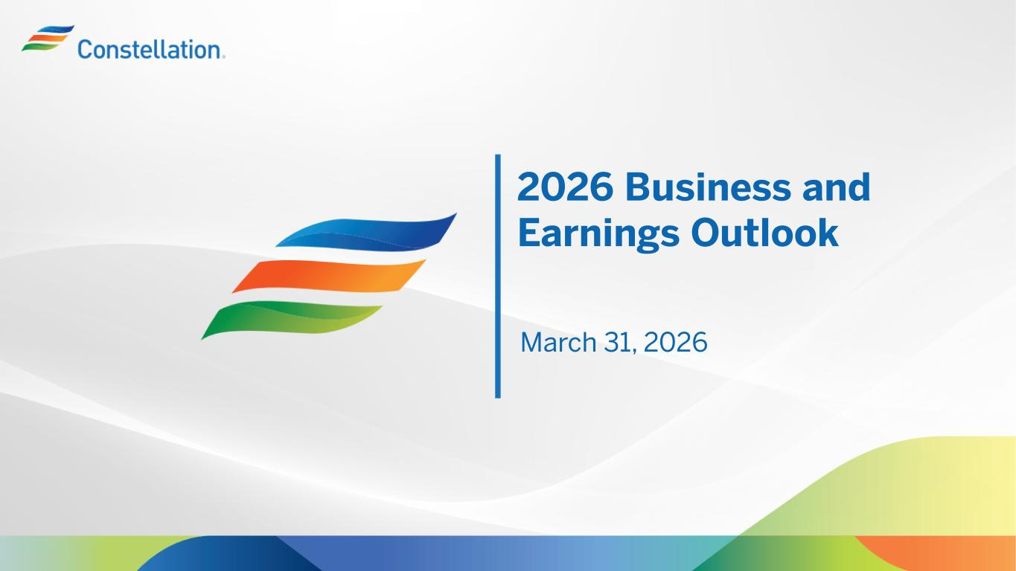

2026 Business and Earnings Outlook March 31, 2026

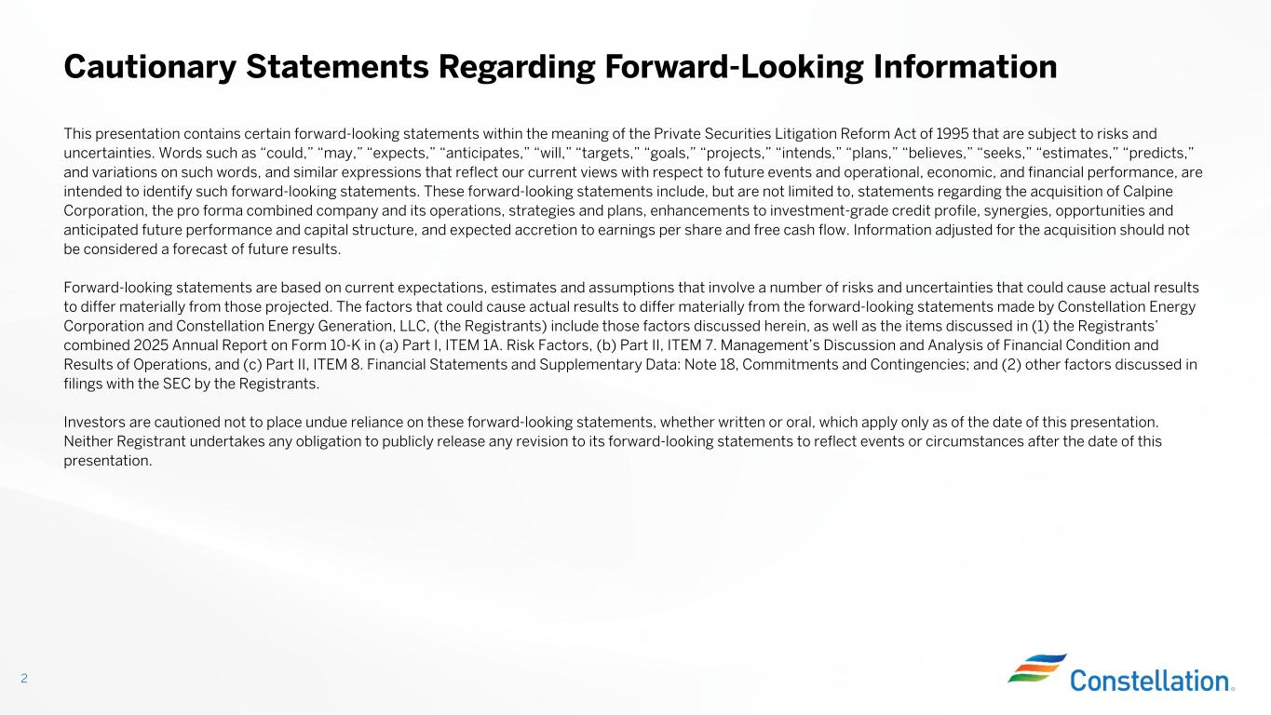
This presentation contains certain forward-looking statements within the meaning of the Private Securities Litigation Reform Act of 1995 that are subject to risks and uncertainties. Words such as “could,” “may,” “expects,” “anticipates,” “will,” “targets,” “goals,” “projects,” “intends,” “plans,” “believes,” “seeks,” “estimates,” “predicts,” and variations on such words, and similar expressions that reflect our current views with respect to future events and operational, economic, and financial performance, are intended to identify such forward-looking statements. These forward-looking statements include, but are not limited to, statements regarding the acquisition of Calpine Corporation, the pro forma combined company and its operations, strategies and plans, enhancements to investment-grade credit profile, synergies, opportunities and anticipated future performance and capital structure, and expected accretion to earnings per share and free cash flow. Information adjusted for the acquisition should not be considered a forecast of future results. Forward-looking statements are based on current expectations, estimates and assumptions that involve a number of risks and uncertainties that could cause actual results to differ materially from those projected. The factors that could cause actual results to differ materially from the forward-looking statements made by Constellation Energy Corporation and Constellation Energy Generation, LLC, (the Registrants) include those factors discussed herein, as well as the items discussed in (1) the Registrants’ combined 2025 Annual Report on Form 10-K in (a) Part I, ITEM 1A. Risk Factors, (b) Part II, ITEM 7. Management’s Discussion and Analysis of Financial Condition and Results of Operations, and (c) Part II, ITEM 8. Financial Statements and Supplementary Data: Note 18, Commitments and Contingencies; and (2) other factors discussed in filings with the SEC by the Registrants. Investors are cautioned not to place undue reliance on these forward-looking statements, whether written or oral, which apply only as of the date of this presentation. Neither Registrant undertakes any obligation to publicly release any revision to its forward-looking statements to reflect events or circumstances after the date of this presentation. Cautionary Statements Regarding Forward-Looking Information 2

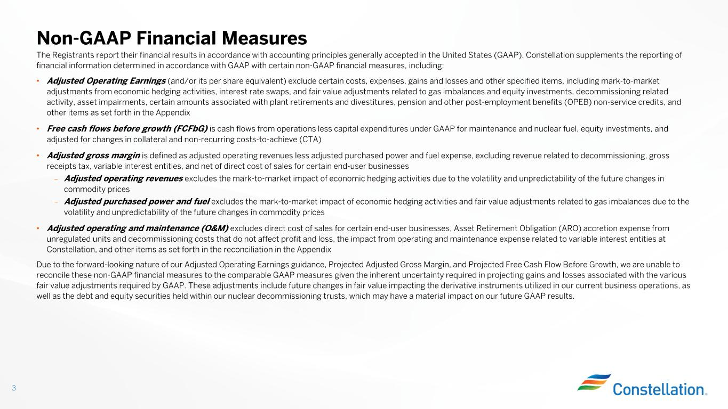
The Registrants report their financial results in accordance with accounting principles generally accepted in the United States (GAAP). Constellation supplements the reporting of financial information determined in accordance with GAAP with certain non-GAAP financial measures, including: • Adjusted Operating Earnings (and/or its per share equivalent) exclude certain costs, expenses, gains and losses and other specified items, including mark-to-market adjustments from economic hedging activities, interest rate swaps, and fair value adjustments related to gas imbalances and equity investments, decommissioning related activity, asset impairments, certain amounts associated with plant retirements and divestitures, pension and other post-employment benefits (OPEB) non-service credits, and other items as set forth in the Appendix • Free cash flows before growth (FCFbG) is cash flows from operations less capital expenditures under GAAP for maintenance and nuclear fuel, equity investments, and adjusted for changes in collateral and non-recurring costs-to-achieve (CTA) • Adjusted gross margin is defined as adjusted operating revenues less adjusted purchased power and fuel expense, excluding revenue related to decommissioning, gross receipts tax, variable interest entities, and net of direct cost of sales for certain end-user businesses – Adjusted operating revenues excludes the mark-to-market impact of economic hedging activities due to the volatility and unpredictability of the future changes in commodity prices – Adjusted purchased power and fuel excludes the mark-to-market impact of economic hedging activities and fair value adjustments related to gas imbalances due to the volatility and unpredictability of the future changes in commodity prices • Adjusted operating and maintenance (O&M) excludes direct cost of sales for certain end-user businesses, Asset Retirement Obligation (ARO) accretion expense from unregulated units and decommissioning costs that do not affect profit and loss, the impact from operating and maintenance expense related to variable interest entities at Constellation, and other items as set forth in the reconciliation in the Appendix Due to the forward-looking nature of our Adjusted Operating Earnings guidance, Projected Adjusted Gross Margin, and Projected Free Cash Flow Before Growth, we are unable to reconcile these non-GAAP financial measures to the comparable GAAP measures given the inherent uncertainty required in projecting gains and losses associated with the various fair value adjustments required by GAAP. These adjustments include future changes in fair value impacting the derivative instruments utilized in our current business operations, as well as the debt and equity securities held within our nuclear decommissioning trusts, which may have a material impact on our future GAAP results. Non-GAAP Financial Measures 3

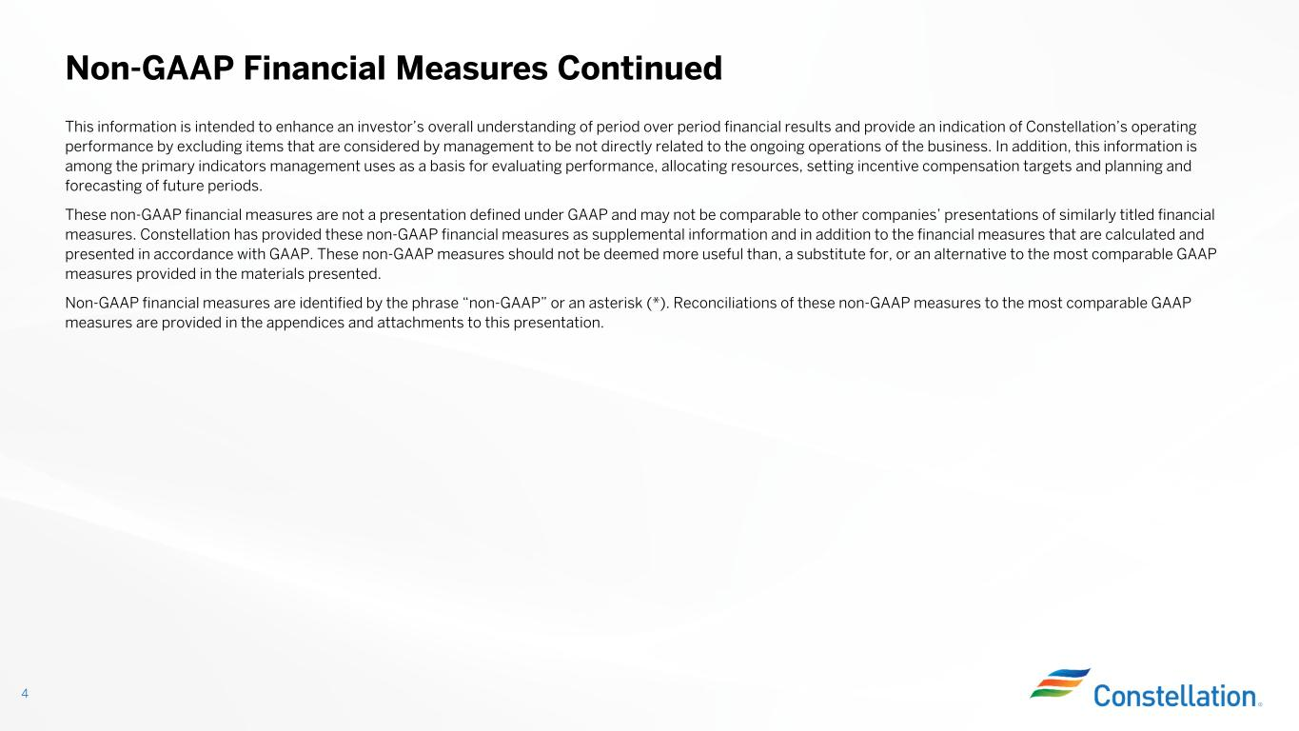
This information is intended to enhance an investor’s overall understanding of period over period financial results and provide an indication of Constellation’s operating performance by excluding items that are considered by management to be not directly related to the ongoing operations of the business. In addition, this information is among the primary indicators management uses as a basis for evaluating performance, allocating resources, setting incentive compensation targets and planning and forecasting of future periods. These non-GAAP financial measures are not a presentation defined under GAAP and may not be comparable to other companies’ presentations of similarly titled financial measures. Constellation has provided these non-GAAP financial measures as supplemental information and in addition to the financial measures that are calculated and presented in accordance with GAAP. These non-GAAP measures should not be deemed more useful than, a substitute for, or an alternative to the most comparable GAAP measures provided in the materials presented. Non-GAAP financial measures are identified by the phrase “non-GAAP” or an asterisk (*). Reconciliations of these non-GAAP measures to the most comparable GAAP measures are provided in the appendices and attachments to this presentation. Non-GAAP Financial Measures Continued 4


Constellation Leads With Unmatched Opportunity

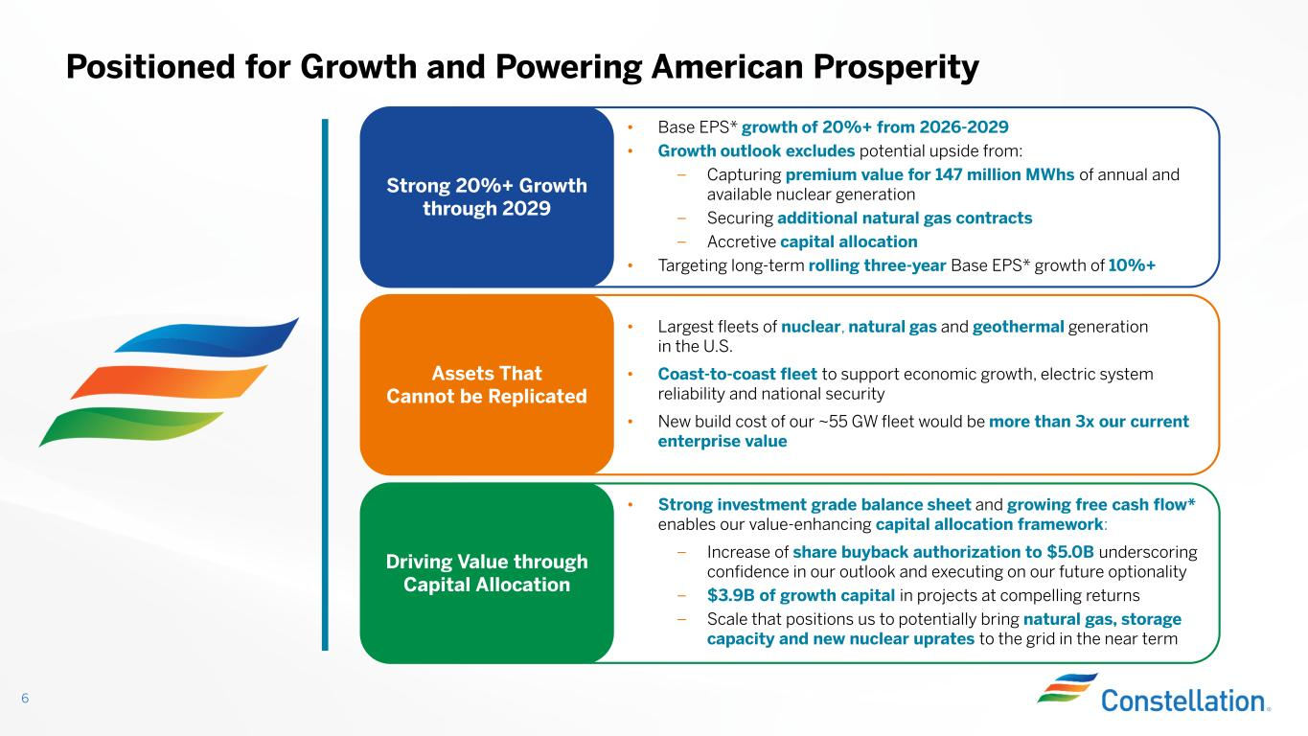
Positioned for Growth and Powering American Prosperity 6 Strong 20%+ Growth through 2029 • Base EPS* growth of 20%+ from 2026-2029 • Growth outlook excludes potential upside from: – Capturing premium value for 147 million MWhs of annual and available nuclear generation – Securing additional natural gas contracts – Accretive capital allocation • Targeting long-term rolling three-year Base EPS* growth of 10%+ Assets That Cannot be Replicated • Largest fleets of nuclear, natural gas and geothermal generation in the U.S. • Coast-to-coast fleet to support economic growth, electric system reliability and national security • New build cost of our ~55 GW fleet would be more than 3x our current enterprise value Driving Value through Capital Allocation • Strong investment grade balance sheet and growing free cash flow* enables our value-enhancing capital allocation framework: – Increase of share buyback authorization to $5.0B underscoring confidence in our outlook and executing on our future optionality – $3.9B of growth capital in projects at compelling returns – Scale that positions us to potentially bring natural gas, storage capacity and new nuclear uprates to the grid in the near term

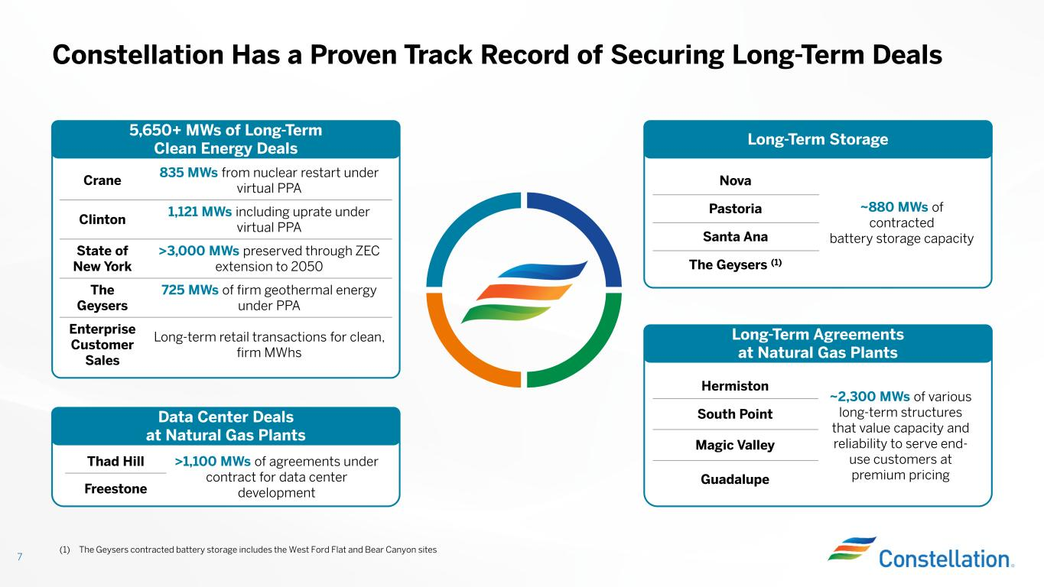
~2,300 MWs of various long-term structures that value capacity and reliability to serve end- use customers at premium pricing Hermiston South Point Magic Valley Guadalupe Constellation Has a Proven Track Record of Securing Long-Term Deals 7 835 MWs from nuclear restart under virtual PPA Crane 1,121 MWs including uprate under virtual PPA Clinton >3,000 MWs preserved through ZEC extension to 2050 State of New York 725 MWs of firm geothermal energy under PPA The Geysers Long-term retail transactions for clean, firm MWhs Enterprise Customer Sales >1,100 MWs of agreements under contract for data center development Thad Hill Freestone ~880 MWs of contracted battery storage capacity Nova Pastoria Santa Ana The Geysers (1) (1) The Geysers contracted battery storage includes the West Ford Flat and Bear Canyon sites 5,650+ MWs of Long-Term Clean Energy Deals Long-Term Storage Data Center Deals at Natural Gas Plants Long-Term Agreements at Natural Gas Plants

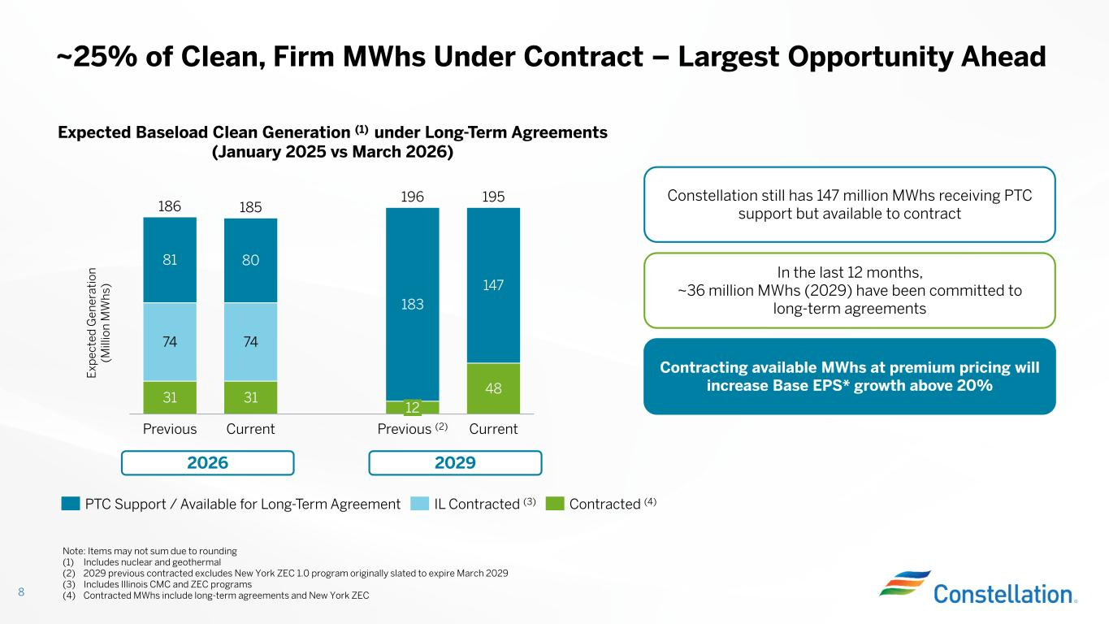
~25% of Clean, Firm MWhs Under Contract – Largest Opportunity Ahead 8 E xp ec te d G en er at io n (M ill io n M W h s) Note: Items may not sum due to rounding (1) Includes nuclear and geothermal (2) 2029 previous contracted excludes New York ZEC 1.0 program originally slated to expire March 2029 (3) Includes Illinois CMC and ZEC programs (4) Contracted MWhs include long-term agreements and New York ZEC In the last 12 months, ~36 million MWhs (2029) have been committed to long-term agreements 31 31 48 74 74 183 147 81 80 Previous Current 12 Previous (2) Current 186 185 196 195 PTC Support / Available for Long-Term Agreement IL Contracted (3) Contracted (4) Expected Baseload Clean Generation (1) under Long-Term Agreements (January 2025 vs March 2026) 2026 2029 Constellation still has 147 million MWhs receiving PTC support but available to contract Contracting available MWhs at premium pricing will increase Base EPS* growth above 20%

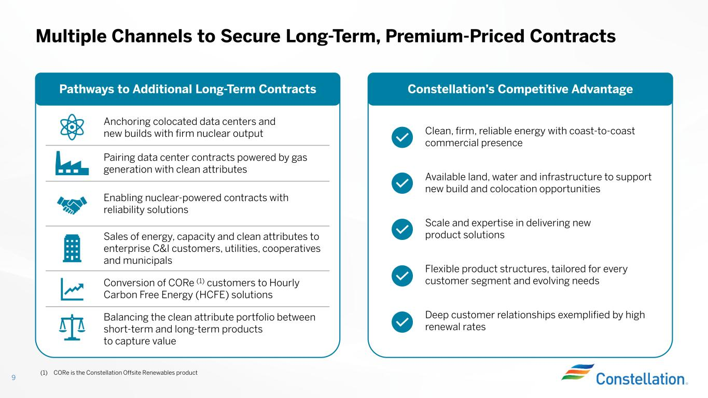
Multiple Channels to Secure Long-Term, Premium-Priced Contracts 9 Clean, firm, reliable energy with coast-to-coast commercial presence Available land, water and infrastructure to support new build and colocation opportunities Scale and expertise in delivering new product solutions Flexible product structures, tailored for every customer segment and evolving needs Deep customer relationships exemplified by high renewal rates Anchoring colocated data centers and new builds with firm nuclear output Pairing data center contracts powered by gas generation with clean attributes Enabling nuclear-powered contracts with reliability solutions Sales of energy, capacity and clean attributes to enterprise C&I customers, utilities, cooperatives and municipals Conversion of CORe (1) customers to Hourly Carbon Free Energy (HCFE) solutions Balancing the clean attribute portfolio between short-term and long-term products to capture value Pathways to Additional Long-Term Contracts Constellation’s Competitive Advantage (1) CORe is the Constellation Offsite Renewables product

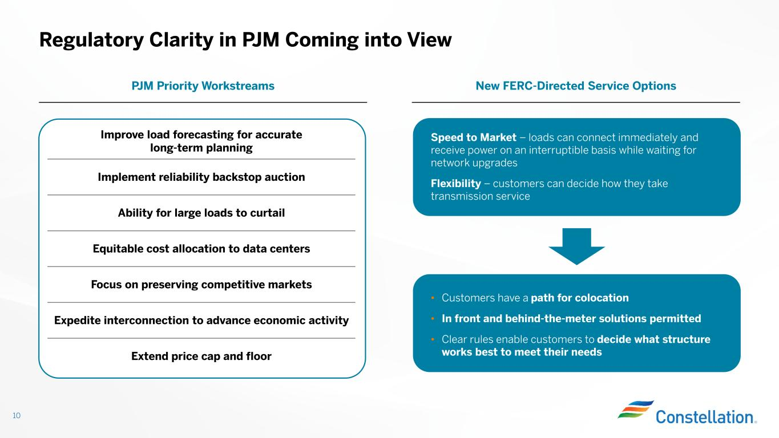
Regulatory Clarity in PJM Coming into View 10 Speed to Market – loads can connect immediately and receive power on an interruptible basis while waiting for network upgrades Flexibility – customers can decide how they take transmission service • Customers have a path for colocation • In front and behind-the-meter solutions permitted • Clear rules enable customers to decide what structure works best to meet their needs New FERC-Directed Service OptionsPJM Priority Workstreams Improve load forecasting for accurate long-term planning Implement reliability backstop auction Ability for large loads to curtail Equitable cost allocation to data centers Focus on preserving competitive markets Expedite interconnection to advance economic activity Extend price cap and floor

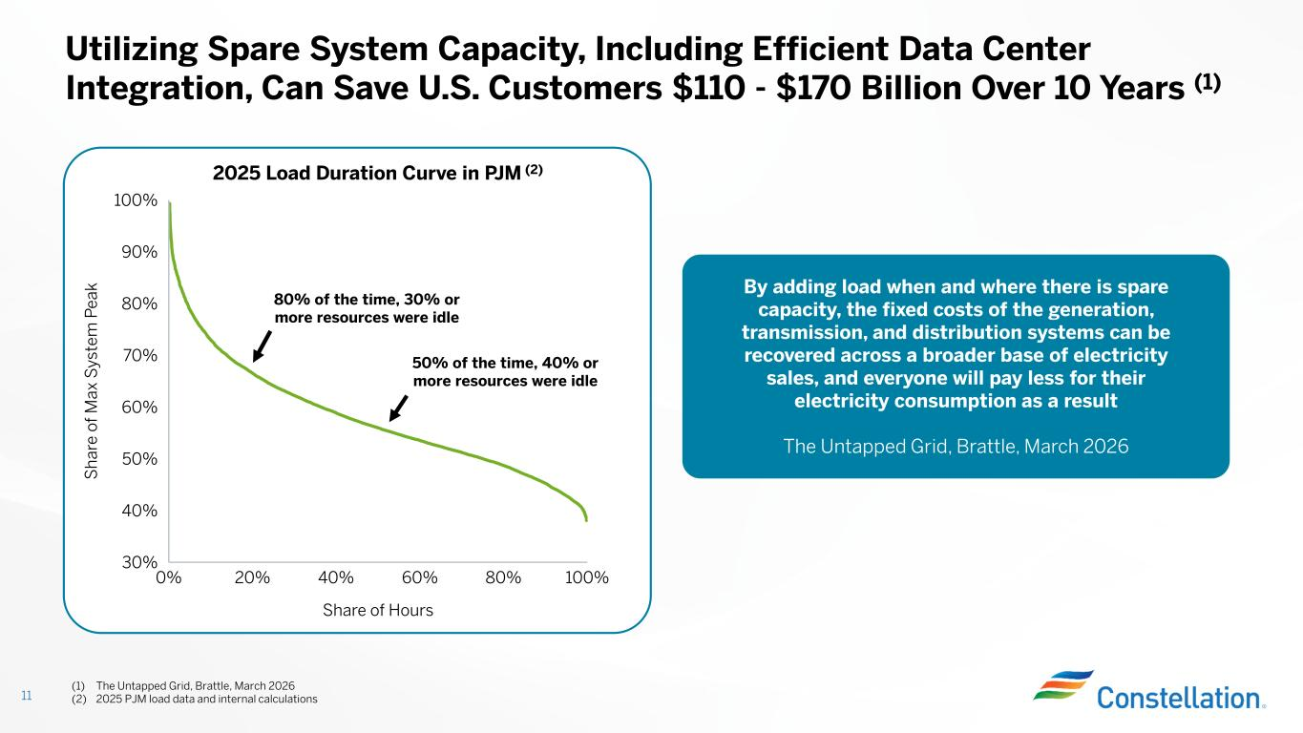
0% 20% 40% 60% 80% 100% 30% 40% 50% 60% 70% 80% 90% 100% Share of Hours S h ar e of M ax S ys te m P ea k Utilizing Spare System Capacity, Including Efficient Data Center Integration, Can Save U.S. Customers $110 - $170 Billion Over 10 Years (1) 11 50% of the time, 40% or more resources were idle 80% of the time, 30% or more resources were idle (1) The Untapped Grid, Brattle, March 2026 (2) 2025 PJM load data and internal calculations By adding load when and where there is spare capacity, the fixed costs of the generation, transmission, and distribution systems can be recovered across a broader base of electricity sales, and everyone will pay less for their electricity consumption as a result The Untapped Grid, Brattle, March 2026 2025 Load Duration Curve in PJM (2)

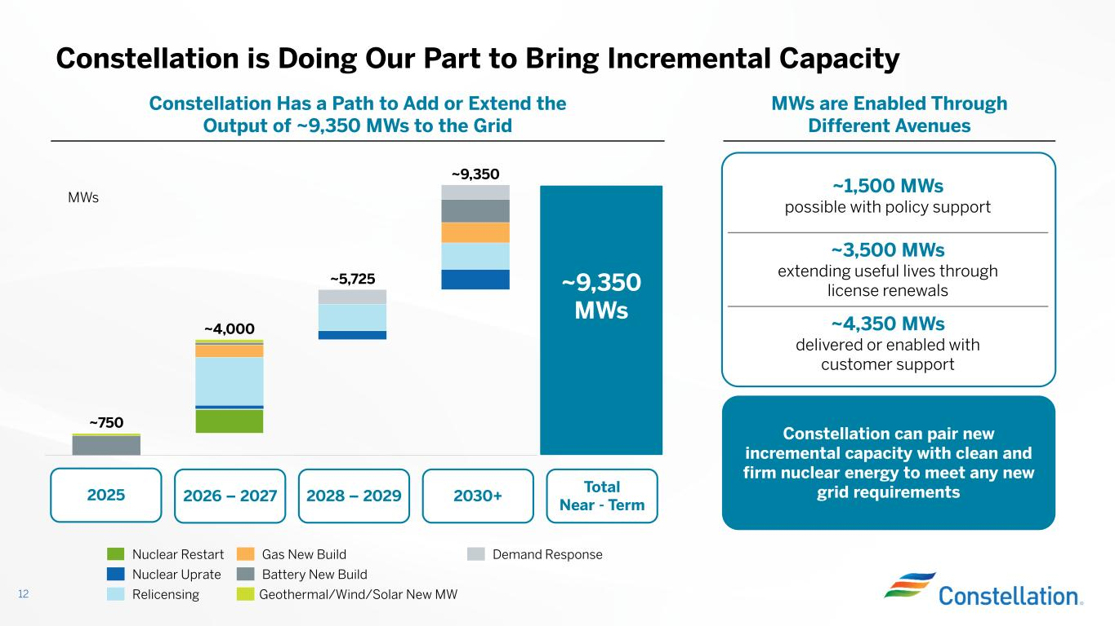
~1,500 MWs possible with policy support ~3,500 MWs extending useful lives through license renewals ~4,350 MWs delivered or enabled with customer support Constellation is Doing Our Part to Bring Incremental Capacity 12 2026 – 2027 2030+2028 – 2029 ~9,350 MWs Total Near - Term ~750 ~4,000 ~5,725 ~9,350 Nuclear Restart Nuclear Uprate Relicensing Gas New Build Battery New Build Geothermal/Wind/Solar New MW Demand Response MWs 2025 MWs are Enabled Through Different Avenues Constellation Has a Path to Add or Extend the Output of ~9,350 MWs to the Grid Constellation can pair new incremental capacity with clean and firm nuclear energy to meet any new grid requirements

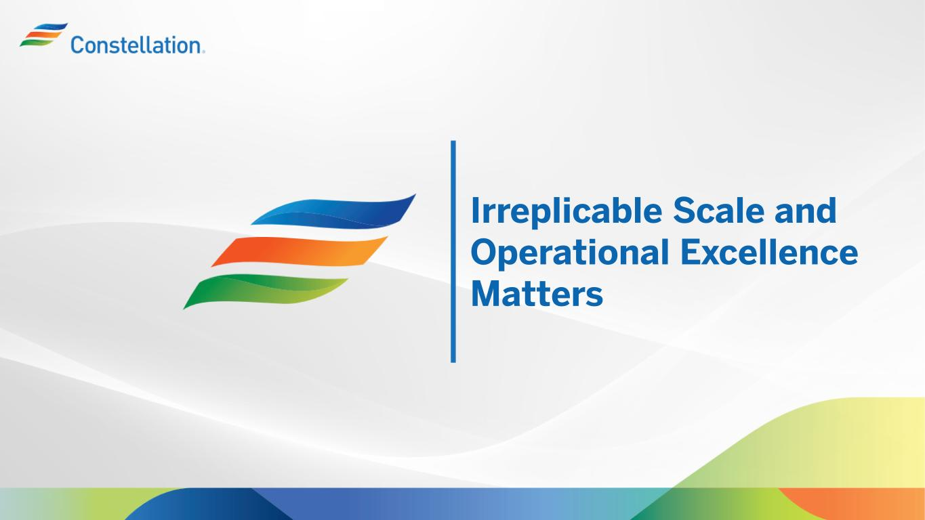
Irreplicable Scale and Operational Excellence Matters

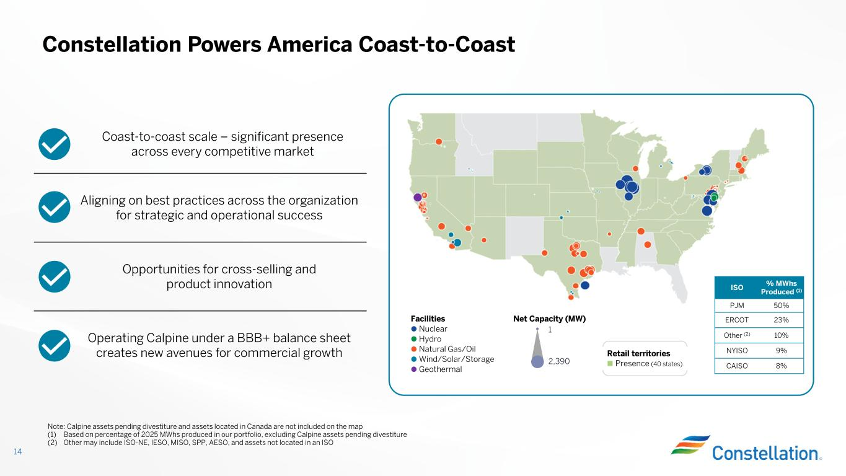
14 Constellation Powers America Coast-to-Coast Aligning on best practices across the organization for strategic and operational success Opportunities for cross-selling and product innovation Operating Calpine under a BBB+ balance sheet creates new avenues for commercial growth Note: Calpine assets pending divestiture and assets located in Canada are not included on the map (1) Based on percentage of 2025 MWhs produced in our portfolio, excluding Calpine assets pending divestiture (2) Other may include ISO-NE, IESO, MISO, SPP, AESO, and assets not located in an ISO Coast-to-coast scale – significant presence across every competitive market Retail territories Presence (40 states) Net Capacity (MW) 1 2,390 Facilities Nuclear Hydro Natural Gas/Oil Wind/Solar/Storage Geothermal % MWhs Produced (1)ISO 50%PJM 23%ERCOT 10%Other (2) 9%NYISO 8%CAISO

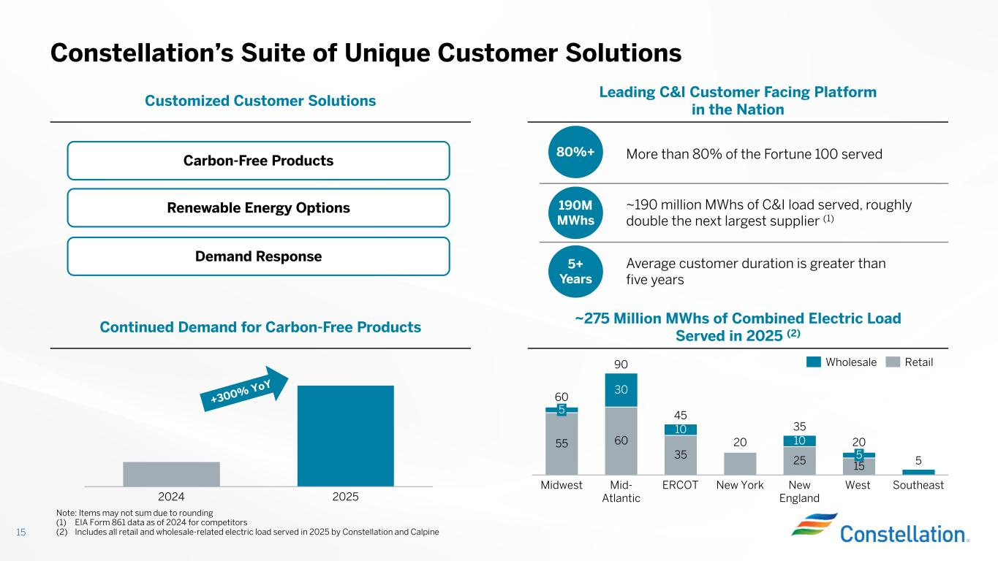
15 Constellation’s Suite of Unique Customer Solutions Leading C&I Customer Facing Platform in the Nation Customized Customer Solutions More than 80% of the Fortune 100 served ~190 million MWhs of C&I load served, roughly double the next largest supplier (1) Average customer duration is greater than five years ~275 Million MWhs of Combined Electric Load Served in 2025 (2)Continued Demand for Carbon-Free Products 2024 2025 Renewable Energy Options Carbon-Free Products Demand Response 55 60 35 20 25 15 30 10 10 5 Midwest Mid- Atlantic ERCOT New York New England 5 West Southeast 60 90 45 35 20 5 Wholesale Retail Note: Items may not sum due to rounding (1) EIA Form 861 data as of 2024 for competitors (2) Includes all retail and wholesale-related electric load served in 2025 by Constellation and Calpine 80%+ 190M MWhs 5+ Years

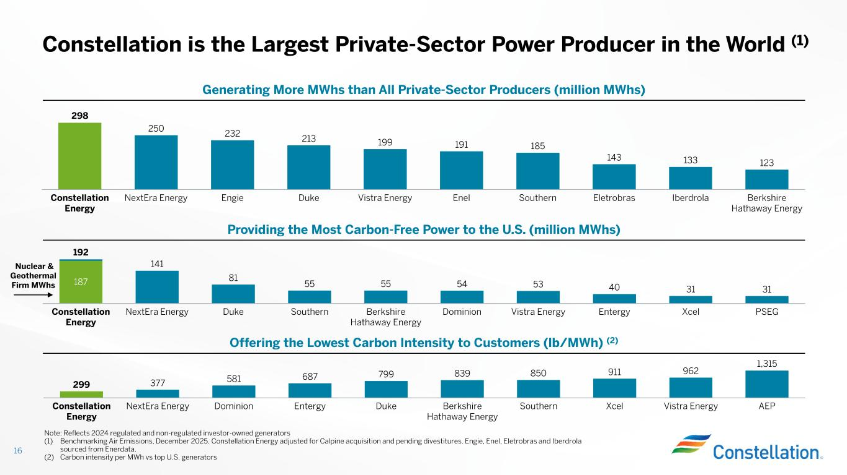
Nuclear & Geothermal Firm MWhs Constellation is the Largest Private-Sector Power Producer in the World (1) 16 298 250 232 213 199 191 185 143 133 123 Constellation Energy NextEra Energy Engie Duke Vistra Energy Enel Southern Eletrobras Iberdrola Berkshire Hathaway Energy Providing the Most Carbon-Free Power to the U.S. (million MWhs) 187 Constellation Energy NextEra Energy Duke Southern Berkshire Hathaway Energy Dominion Vistra Energy Entergy Xcel PSEG 192 141 81 55 55 54 53 40 31 31 Generating More MWhs than All Private-Sector Producers (million MWhs) Offering the Lowest Carbon Intensity to Customers (lb/MWh) (2) 299 377 581 687 799 839 850 911 962 1,315 Constellation Energy NextEra Energy Dominion Entergy Duke Berkshire Hathaway Energy Southern Xcel Vistra Energy AEP Note: Reflects 2024 regulated and non-regulated investor-owned generators (1) Benchmarking Air Emissions, December 2025. Constellation Energy adjusted for Calpine acquisition and pending divestitures. Engie, Enel, Eletrobras and Iberdrola sourced from Enerdata. (2) Carbon intensity per MWh vs top U.S. generators

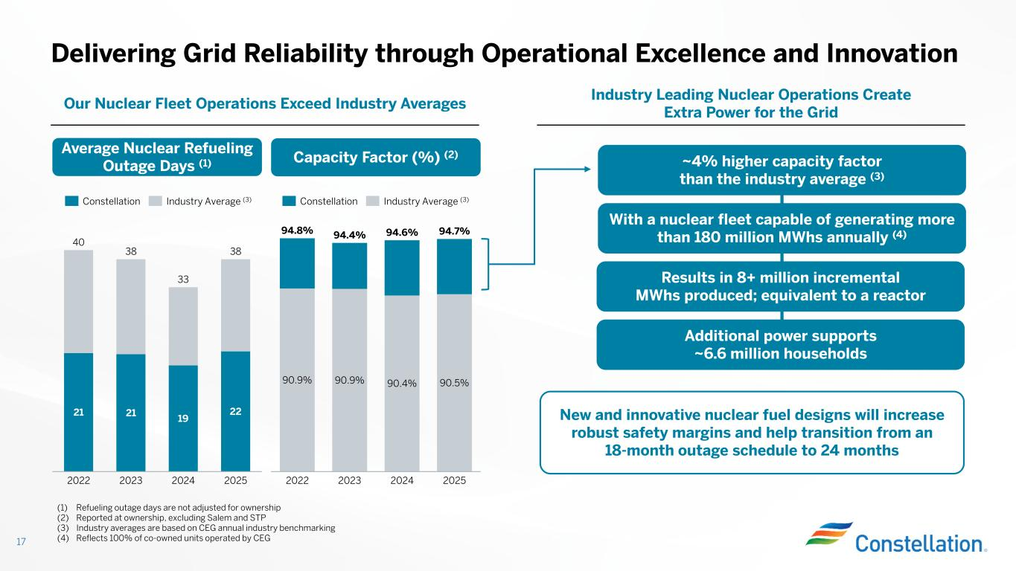
Delivering Grid Reliability through Operational Excellence and Innovation 17 (1) Refueling outage days are not adjusted for ownership (2) Reported at ownership, excluding Salem and STP (3) Industry averages are based on CEG annual industry benchmarking (4) Reflects 100% of co-owned units operated by CEG Industry Leading Nuclear Operations Create Extra Power for the Grid Our Nuclear Fleet Operations Exceed Industry Averages ~4% higher capacity factor than the industry average (3) With a nuclear fleet capable of generating more than 180 million MWhs annually (4) Results in 8+ million incremental MWhs produced; equivalent to a reactor Additional power supports ~6.6 million households Average Nuclear Refueling Outage Days (1) Capacity Factor (%) (2) 90.9% 90.9% 90.4% 90.5% 2022 2023 2024 2025 94.8% 94.4% 94.6% 94.7% 21 21 19 22 2022 2023 2024 2025 40 38 33 38 Constellation Industry Average (3) Constellation Industry Average (3) New and innovative nuclear fuel designs will increase robust safety margins and help transition from an 18-month outage schedule to 24 months

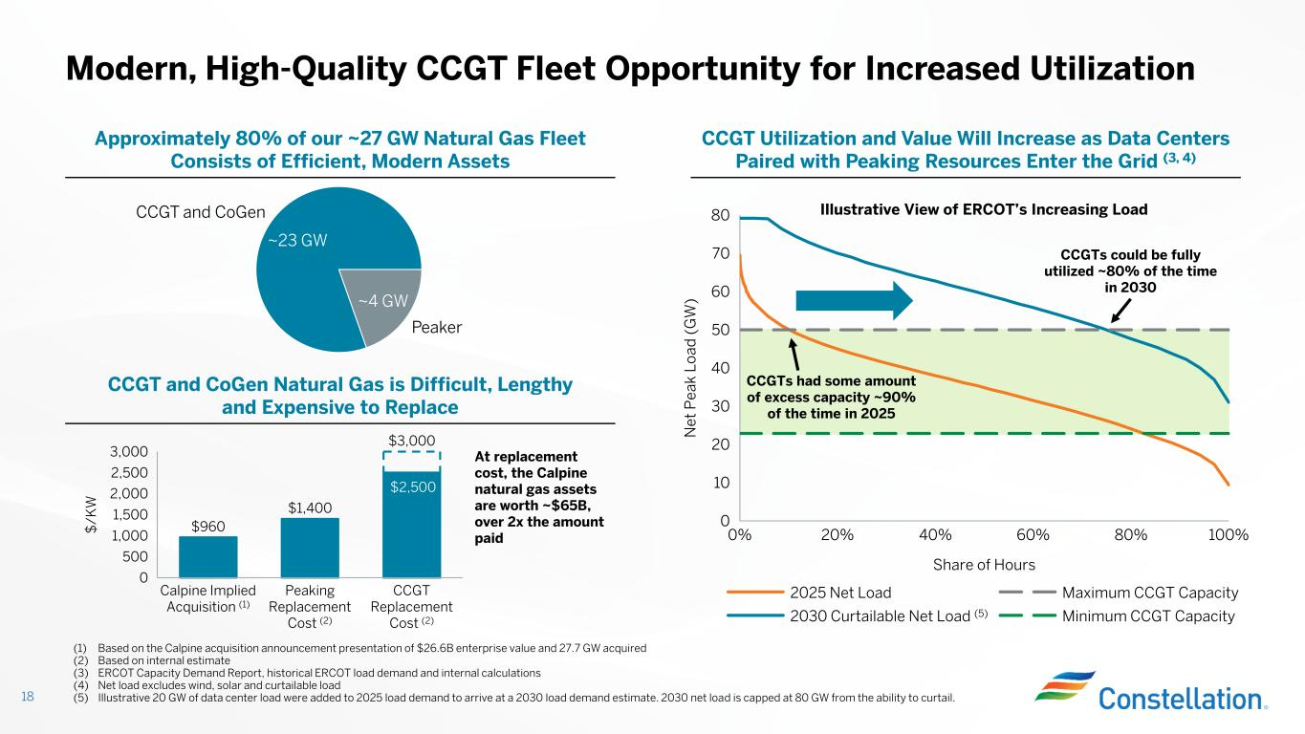
Modern, High-Quality CCGT Fleet Opportunity for Increased Utilization 18 CCGT Utilization and Value Will Increase as Data Centers Paired with Peaking Resources Enter the Grid (3, 4) Approximately 80% of our ~27 GW Natural Gas Fleet Consists of Efficient, Modern Assets ~4 GW Peaker ~23 GW CCGT and CoGen 0% 20% 40% 60% 80% 100% 0 10 20 30 40 50 60 70 80 Share of Hours N et P ea k Lo ad ( G W ) 2025 Net Load 2030 Curtailable Net Load (5) Maximum CCGT Capacity Minimum CCGT Capacity CCGTs had some amount of excess capacity ~90% of the time in 2025 CCGTs could be fully utilized ~80% of the time in 2030 (1) Based on the Calpine acquisition announcement presentation of $26.6B enterprise value and 27.7 GW acquired (2) Based on internal estimate (3) ERCOT Capacity Demand Report, historical ERCOT load demand and internal calculations (4) Net load excludes wind, solar and curtailable load (5) Illustrative 20 GW of data center load were added to 2025 load demand to arrive at a 2030 load demand estimate. 2030 net load is capped at 80 GW from the ability to curtail. CCGT and CoGen Natural Gas is Difficult, Lengthy and Expensive to Replace At replacement cost, the Calpine natural gas assets are worth ~$65B, over 2x the amount paid Illustrative View of ERCOT’s Increasing Load $960 $1,400 0 500 1,000 1,500 2,000 2,500 3,000 $ /K W Calpine Implied Acquisition (1) Peaking Replacement Cost (2) CCGT Replacement Cost (2) $3,000 $2,500

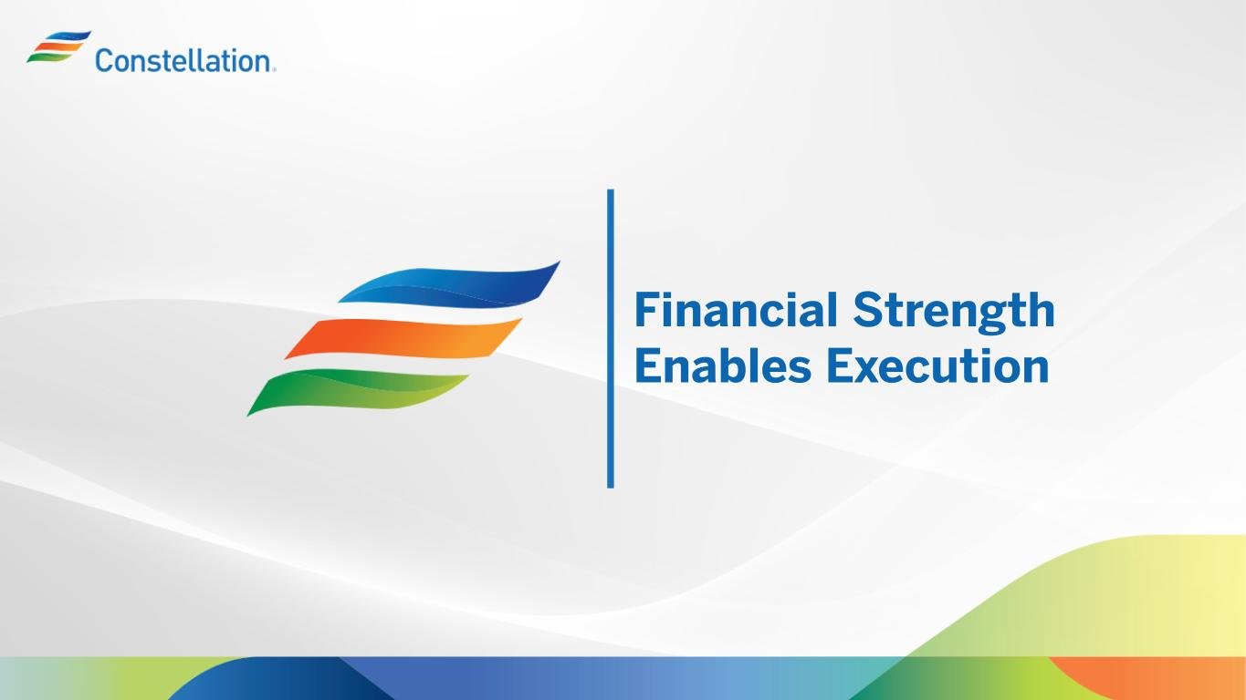
Financial Strength Enables Execution

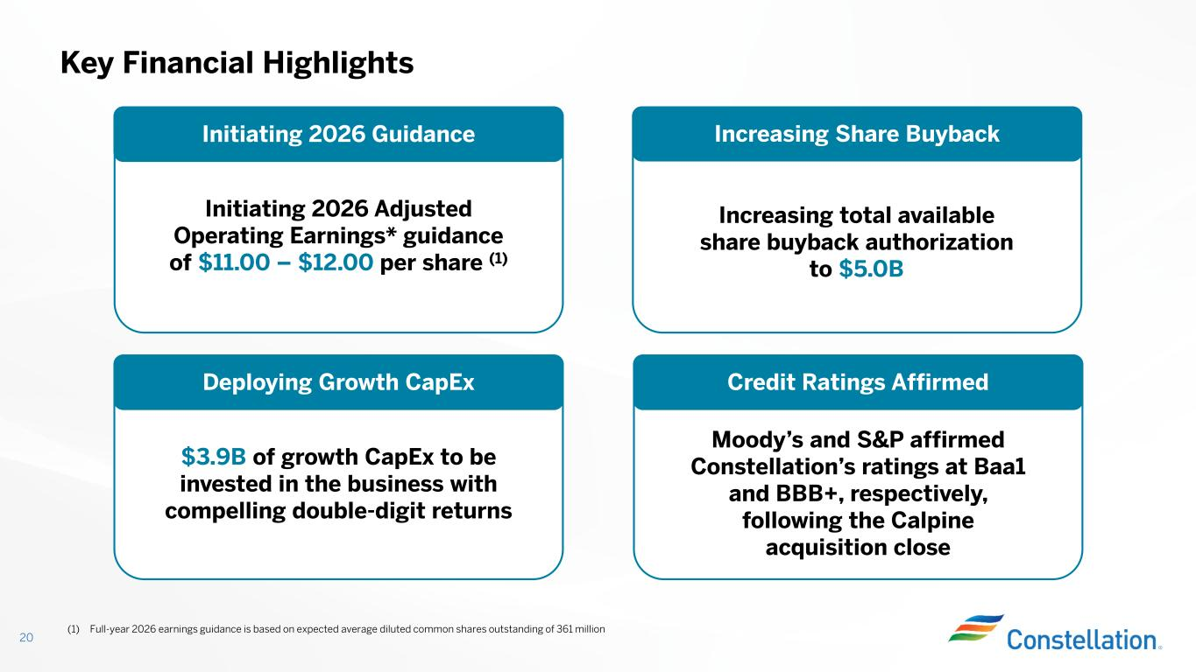
Key Financial Highlights 20 Initiating 2026 Adjusted Operating Earnings* guidance of $11.00 – $12.00 per share (1) Initiating 2026 Guidance Increasing Share Buyback Deploying Growth CapEx Credit Ratings Affirmed Increasing total available share buyback authorization to $5.0B $3.9B of growth CapEx to be invested in the business with compelling double-digit returns (1) Full-year 2026 earnings guidance is based on expected average diluted common shares outstanding of 361 million Moody’s and S&P affirmed Constellation’s ratings at Baa1 and BBB+, respectively, following the Calpine acquisition close

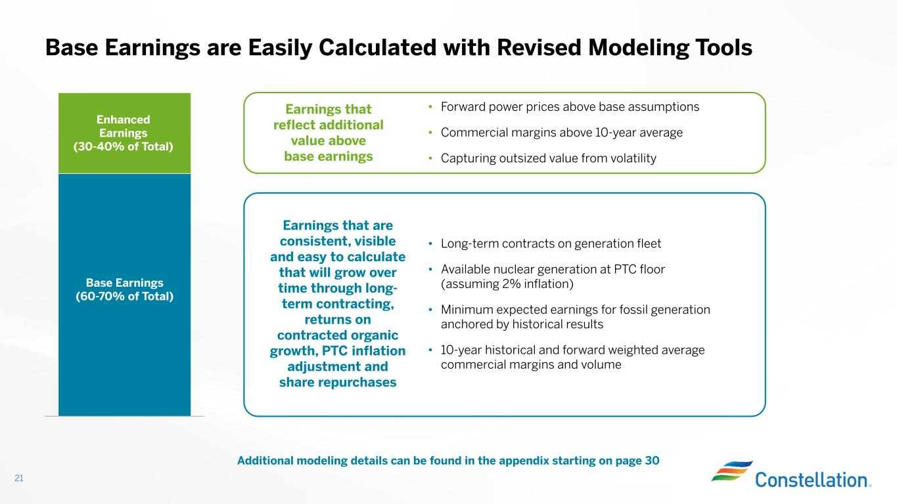
Base Earnings are Easily Calculated with Revised Modeling Tools 21 Additional modeling details can be found in the appendix starting on page 30 Enhanced Earnings (30-40% of Total) Base Earnings (60-70% of Total) Earnings that reflect additional value above base earnings Earnings that are consistent, visible and easy to calculate that will grow over time through long- term contracting, returns on contracted organic growth, PTC inflation adjustment and share repurchases • Forward power prices above base assumptions • Commercial margins above 10-year average • Capturing outsized value from volatility • Long-term contracts on generation fleet • Available nuclear generation at PTC floor (assuming 2% inflation) • Minimum expected earnings for fossil generation anchored by historical results • 10-year historical and forward weighted average commercial margins and volume

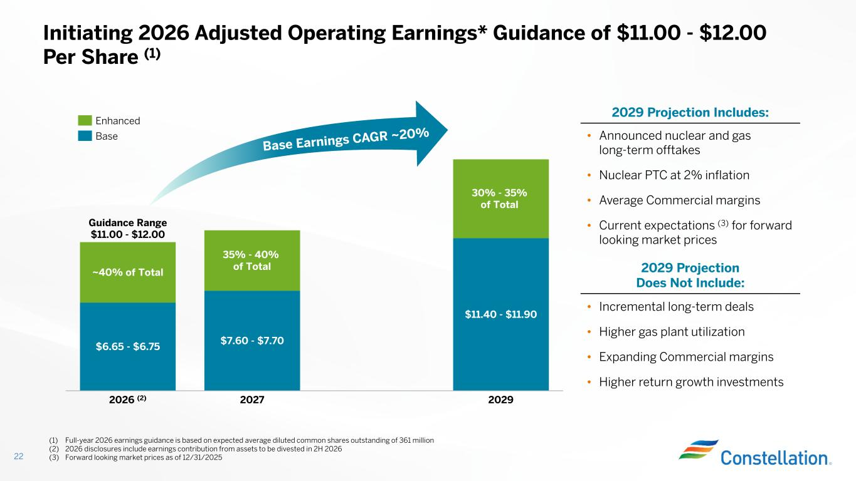
Initiating 2026 Adjusted Operating Earnings* Guidance of $11.00 - $12.00 Per Share (1) 22 $6.65 - $6.75 ~40% of Total 2026 (2) $7.60 - $7.70 35% - 40% of Total 2027 $11.40 - $11.90 30% - 35% of Total 2029 Guidance Range $11.00 - $12.00 (1) Full-year 2026 earnings guidance is based on expected average diluted common shares outstanding of 361 million (2) 2026 disclosures include earnings contribution from assets to be divested in 2H 2026 (3) Forward looking market prices as of 12/31/2025 2029 Projection Includes: 2029 Projection Does Not Include: • Incremental long-term deals • Higher gas plant utilization • Expanding Commercial margins • Higher return growth investments • Announced nuclear and gas long-term offtakes • Nuclear PTC at 2% inflation • Average Commercial margins • Current expectations (3) for forward looking market prices Enhanced Base

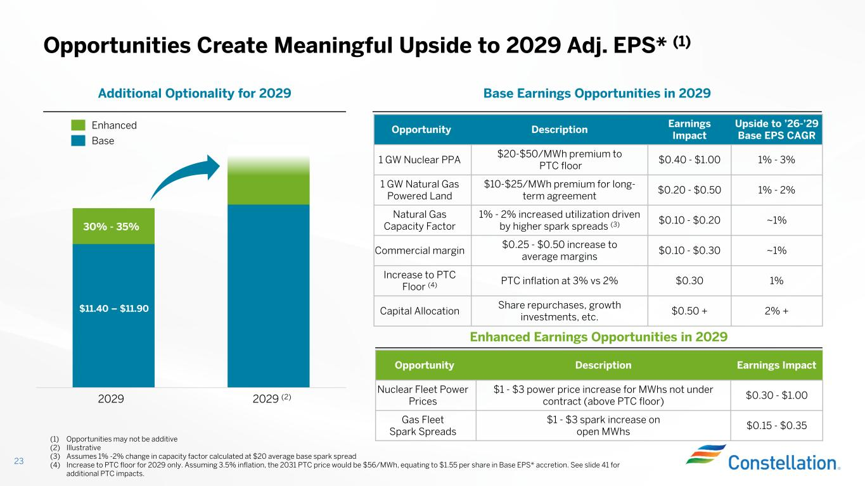
Opportunities Create Meaningful Upside to 2029 Adj. EPS* (1) 23 Base Earnings Opportunities in 2029Additional Optionality for 2029 Earnings ImpactDescriptionOpportunity $0.30 - $1.00 $1 - $3 power price increase for MWhs not under contract (above PTC floor) Nuclear Fleet Power Prices $0.15 - $0.35 $1 - $3 spark increase on open MWhs Gas Fleet Spark Spreads Upside to ’26-’29 Base EPS CAGR Earnings Impact DescriptionOpportunity 1% - 3%$0.40 - $1.00 $20-$50/MWh premium to PTC floor 1 GW Nuclear PPA 1% - 2%$0.20 - $0.50 $10-$25/MWh premium for long- term agreement 1 GW Natural Gas Powered Land ~1%$0.10 - $0.20 1% - 2% increased utilization driven by higher spark spreads (3) Natural Gas Capacity Factor ~1%$0.10 - $0.30 $0.25 - $0.50 increase to average margins Commercial margin 1%$0.30PTC inflation at 3% vs 2% Increase to PTC Floor (4) 2% +$0.50 + Share repurchases, growth investments, etc. Capital Allocation (1) Opportunities may not be additive (2) Illustrative (3) Assumes 1% -2% change in capacity factor calculated at $20 average base spark spread (4) Increase to PTC floor for 2029 only. Assuming 3.5% inflation, the 2031 PTC price would be $56/MWh, equating to $1.55 per share in Base EPS* accretion. See slide 41 for additional PTC impacts. Enhanced Earnings Opportunities in 2029 30% - 35% $11.40 – $11.90 2029 2029 (2) Enhanced Base

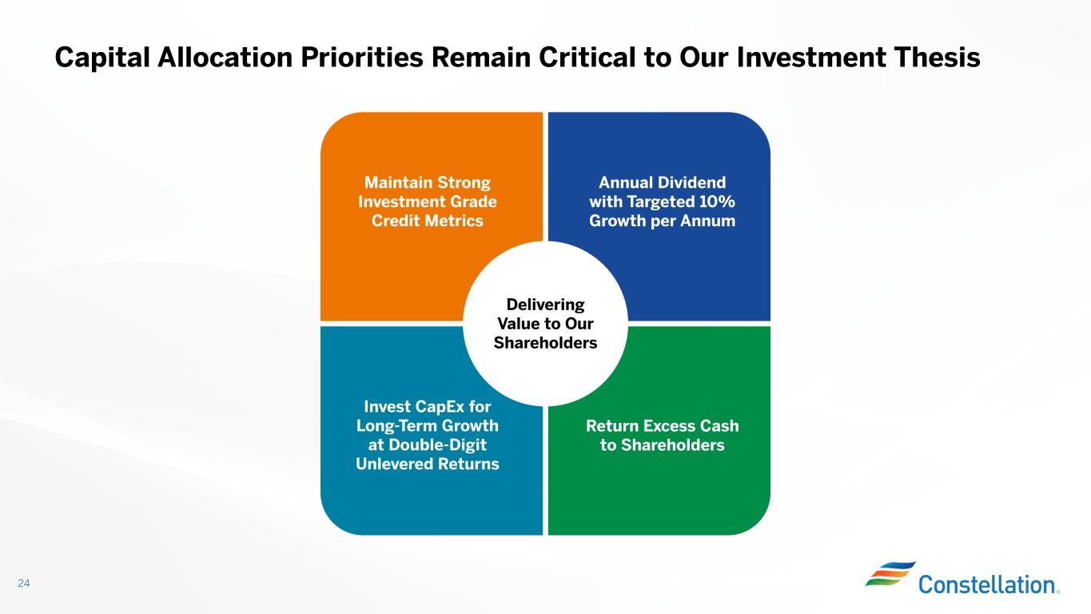
Capital Allocation Priorities Remain Critical to Our Investment Thesis 24 Delivering Value to Our Shareholders Maintain Strong Investment Grade Credit Metrics Annual Dividend with Targeted 10% Growth per Annum Return Excess Cash to Shareholders Invest CapEx for Long-Term Growth at Double-Digit Unlevered Returns

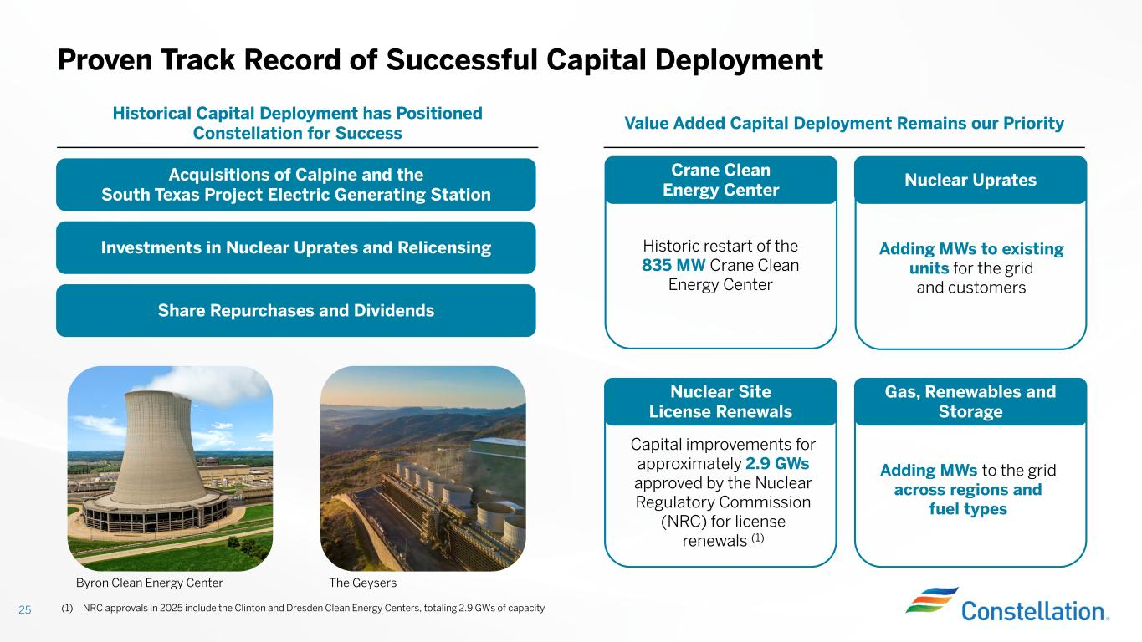
Proven Track Record of Successful Capital Deployment 25 Historic restart of the 835 MW Crane Clean Energy Center Adding MWs to existing units for the grid and customers Adding MWs to the grid across regions and fuel types Gas, Renewables and Storage Nuclear Uprates Capital improvements for approximately 2.9 GWs approved by the Nuclear Regulatory Commission (NRC) for license renewals (1) Acquisitions of Calpine and the South Texas Project Electric Generating Station Value Added Capital Deployment Remains our Priority Historical Capital Deployment has Positioned Constellation for Success Share Repurchases and Dividends Investments in Nuclear Uprates and Relicensing Byron Clean Energy Center The Geysers Crane Clean Energy Center Nuclear Site License Renewals (1) NRC approvals in 2025 include the Clinton and Dresden Clean Energy Centers, totaling 2.9 GWs of capacity

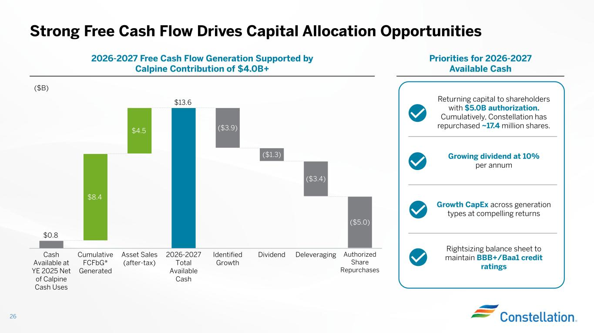
Priorities for 2026-2027 Available Cash 2026-2027 Free Cash Flow Generation Supported by Calpine Contribution of $4.0B+ Strong Free Cash Flow Drives Capital Allocation Opportunities 26 $0.8 $13.6 $8.4 $4.5 Cash Available at YE 2025 Net of Calpine Cash Uses Cumulative FCFbG* Generated Asset Sales (after-tax) 2026-2027 Total Available Cash ($3.9) Identified Growth ($1.3) Dividend ($3.4) Deleveraging ($5.0) Authorized Share Repurchases ($B) Returning capital to shareholders with $5.0B authorization. Cumulatively, Constellation has repurchased ~17.4 million shares. Growing dividend at 10% per annum Growth CapEx across generation types at compelling returns Rightsizing balance sheet to maintain BBB+/Baa1 credit ratings

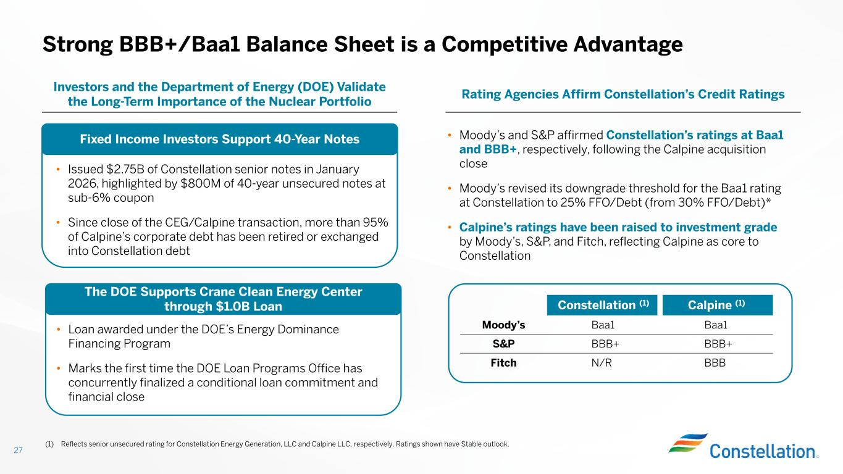
Strong BBB+/Baa1 Balance Sheet is a Competitive Advantage Rating Agencies Affirm Constellation’s Credit Ratings Investors and the Department of Energy (DOE) Validate the Long-Term Importance of the Nuclear Portfolio Fixed Income Investors Support 40-Year Notes • Issued $2.75B of Constellation senior notes in January 2026, highlighted by $800M of 40-year unsecured notes at sub-6% coupon • Since close of the CEG/Calpine transaction, more than 95% of Calpine’s corporate debt has been retired or exchanged into Constellation debt The DOE Supports Crane Clean Energy Center through $1.0B Loan • Loan awarded under the DOE’s Energy Dominance Financing Program • Marks the first time the DOE Loan Programs Office has concurrently finalized a conditional loan commitment and financial close 27 • Moody’s and S&P affirmed Constellation’s ratings at Baa1 and BBB+, respectively, following the Calpine acquisition close • Moody’s revised its downgrade threshold for the Baa1 rating at Constellation to 25% FFO/Debt (from 30% FFO/Debt)* • Calpine’s ratings have been raised to investment grade by Moody’s, S&P, and Fitch, reflecting Calpine as core to Constellation Calpine (1)Constellation (1) Baa1Baa1Moody’s BBB+BBB+S&P BBBN/RFitch (1) Reflects senior unsecured rating for Constellation Energy Generation, LLC and Calpine LLC, respectively. Ratings shown have Stable outlook.

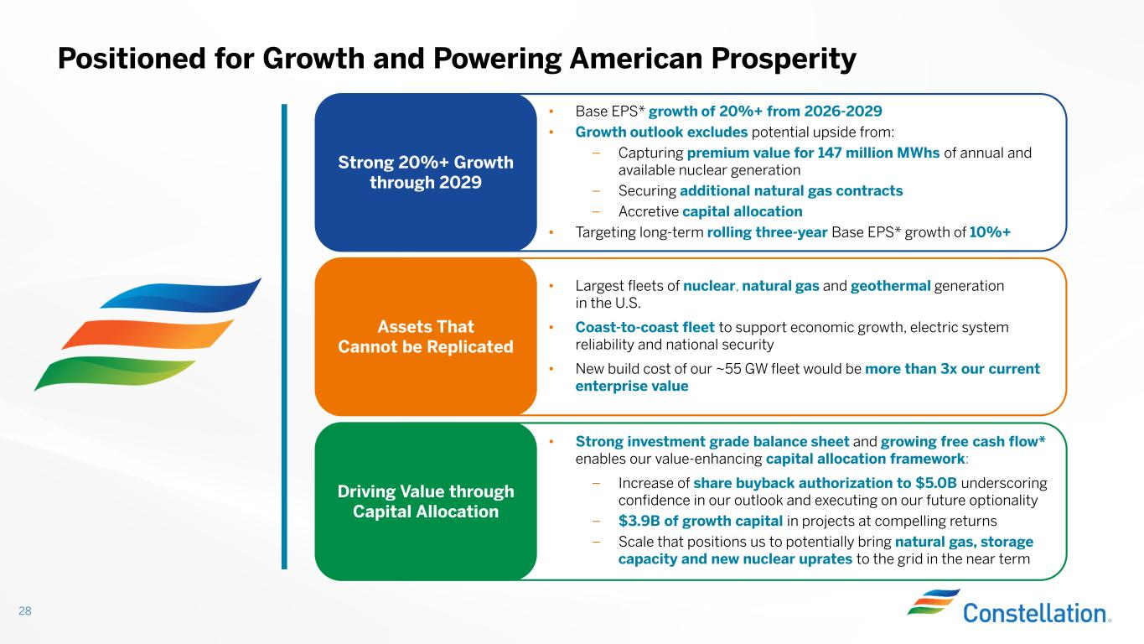
Positioned for Growth and Powering American Prosperity 28 Strong 20%+ Growth through 2029 • Base EPS* growth of 20%+ from 2026-2029 • Growth outlook excludes potential upside from: – Capturing premium value for 147 million MWhs of annual and available nuclear generation – Securing additional natural gas contracts – Accretive capital allocation • Targeting long-term rolling three-year Base EPS* growth of 10%+ Assets That Cannot be Replicated • Largest fleets of nuclear, natural gas and geothermal generation in the U.S. • Coast-to-coast fleet to support economic growth, electric system reliability and national security • New build cost of our ~55 GW fleet would be more than 3x our current enterprise value Driving Value through Capital Allocation • Strong investment grade balance sheet and growing free cash flow* enables our value-enhancing capital allocation framework: – Increase of share buyback authorization to $5.0B underscoring confidence in our outlook and executing on our future optionality – $3.9B of growth capital in projects at compelling returns – Scale that positions us to potentially bring natural gas, storage capacity and new nuclear uprates to the grid in the near term

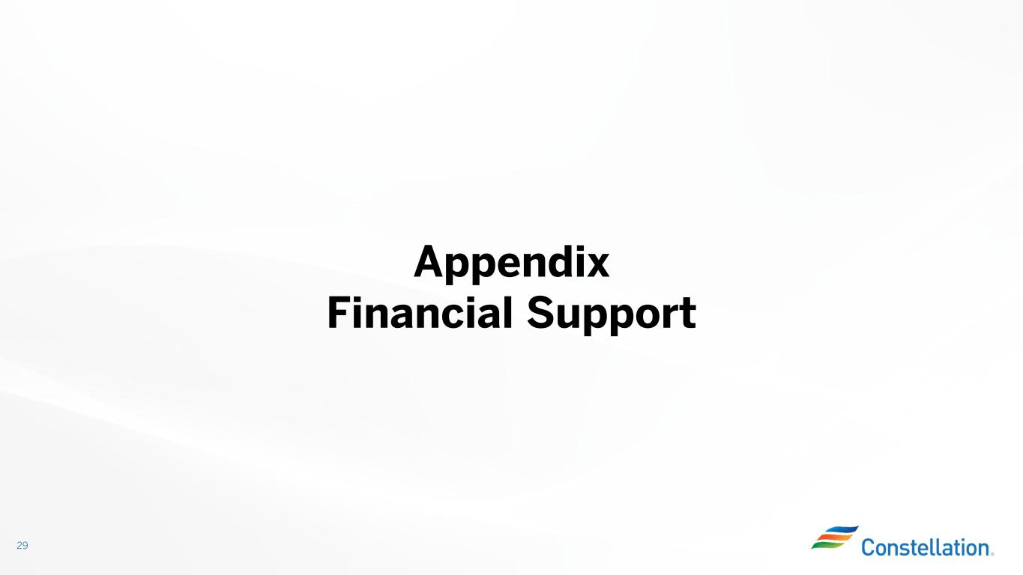
29 Appendix Financial Support

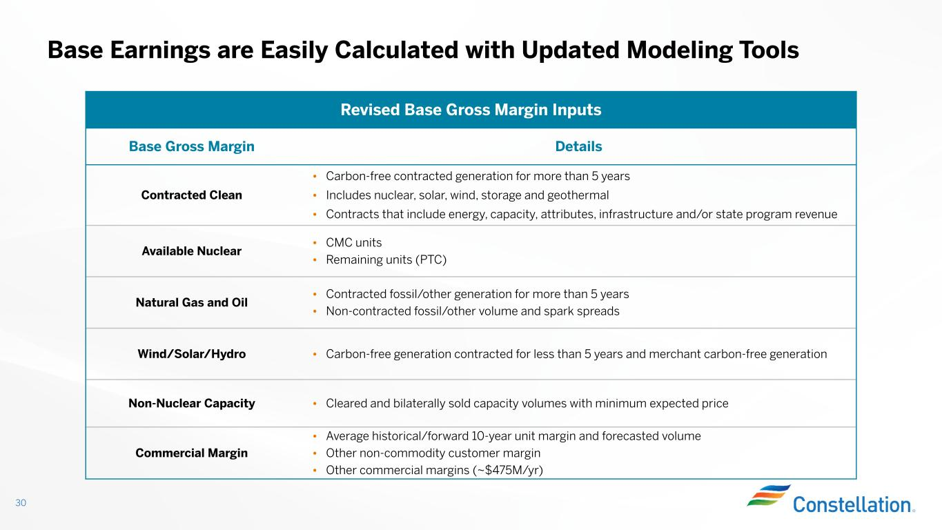
Base Earnings are Easily Calculated with Updated Modeling Tools 30 Revised Base Gross Margin Inputs DetailsBase Gross Margin • Carbon-free contracted generation for more than 5 years • Includes nuclear, solar, wind, storage and geothermal • Contracts that include energy, capacity, attributes, infrastructure and/or state program revenue Contracted Clean • CMC units • Remaining units (PTC) Available Nuclear • Contracted fossil/other generation for more than 5 years • Non-contracted fossil/other volume and spark spreads Natural Gas and Oil • Carbon-free generation contracted for less than 5 years and merchant carbon-free generation Wind/Solar/Hydro • Cleared and bilaterally sold capacity volumes with minimum expected priceNon-Nuclear Capacity • Average historical/forward 10-year unit margin and forecasted volume • Other non-commodity customer margin • Other commercial margins (~$475M/yr) Commercial Margin

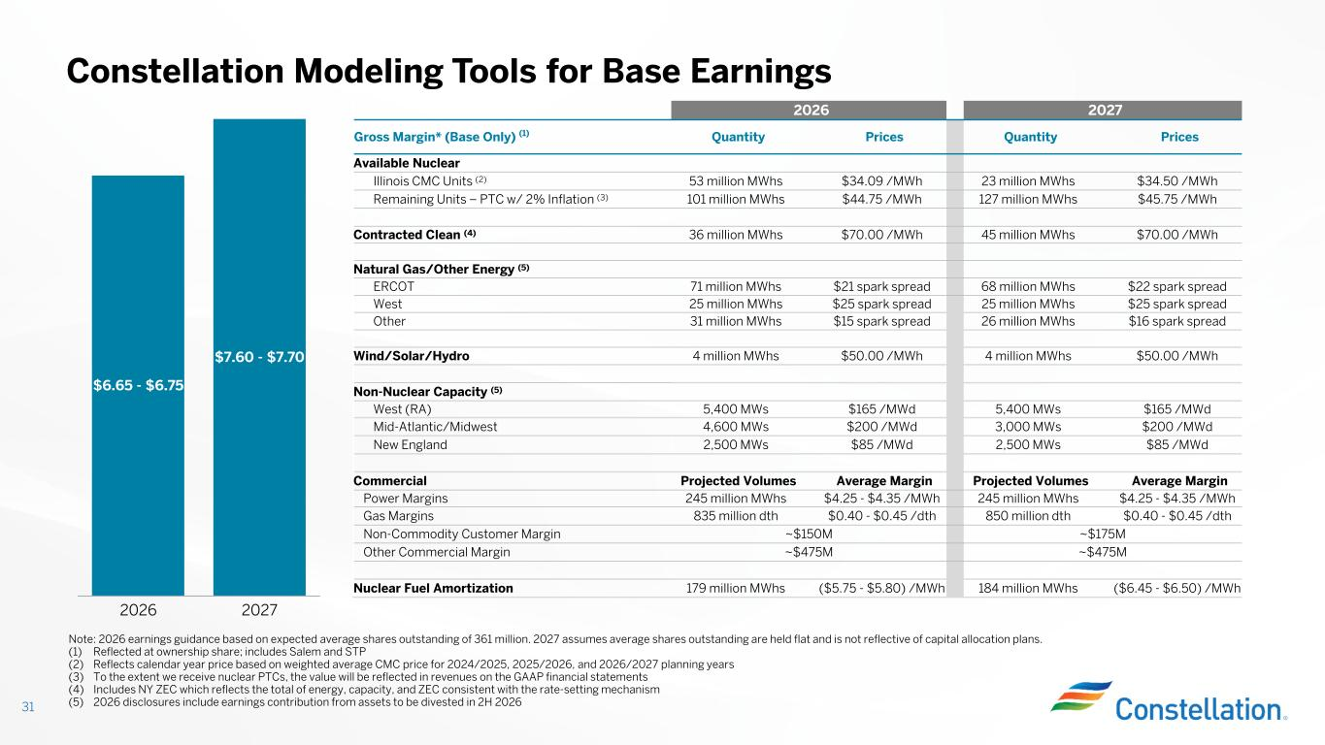
Constellation Modeling Tools for Base Earnings 31 Note: 2026 earnings guidance based on expected average shares outstanding of 361 million. 2027 assumes average shares outstanding are held flat and is not reflective of capital allocation plans. (1) Reflected at ownership share; includes Salem and STP (2) Reflects calendar year price based on weighted average CMC price for 2024/2025, 2025/2026, and 2026/2027 planning years (3) To the extent we receive nuclear PTCs, the value will be reflected in revenues on the GAAP financial statements (4) Includes NY ZEC which reflects the total of energy, capacity, and ZEC consistent with the rate-setting mechanism (5) 2026 disclosures include earnings contribution from assets to be divested in 2H 2026 20272026 PricesQuantityPricesQuantityGross Margin* (Base Only) (1) Available Nuclear $34.50 /MWh23 million MWhs$34.09 /MWh53 million MWhsIllinois CMC Units (2) $45.75 /MWh127 million MWhs$44.75 /MWh101 million MWhsRemaining Units – PTC w/ 2% Inflation (3) $70.00 /MWh45 million MWhs$70.00 /MWh36 million MWhsContracted Clean (4) Natural Gas/Other Energy (5) $22 spark spread68 million MWhs$21 spark spread71 million MWhsERCOT $25 spark spread25 million MWhs$25 spark spread25 million MWhsWest $16 spark spread26 million MWhs$15 spark spread31 million MWhsOther $50.00 /MWh4 million MWhs$50.00 /MWh4 million MWhsWind/Solar/Hydro Non-Nuclear Capacity (5) $165 /MWd5,400 MWs$165 /MWd5,400 MWsWest (RA) $200 /MWd3,000 MWs$200 /MWd4,600 MWsMid-Atlantic/Midwest $85 /MWd2,500 MWs$85 /MWd2,500 MWsNew England Average MarginProjected VolumesAverage MarginProjected VolumesCommercial $4.25 - $4.35 /MWh245 million MWhs$4.25 - $4.35 /MWh245 million MWhsPower Margins $0.40 - $0.45 /dth850 million dth$0.40 - $0.45 /dth835 million dthGas Margins ~$175M~$150MNon-Commodity Customer Margin ~$475M~$475MOther Commercial Margin ($6.45 - $6.50) /MWh184 million MWhs($5.75 - $5.80) /MWh179 million MWhsNuclear Fuel Amortization $6.65 - $6.75 2026 $7.60 - $7.70 2027

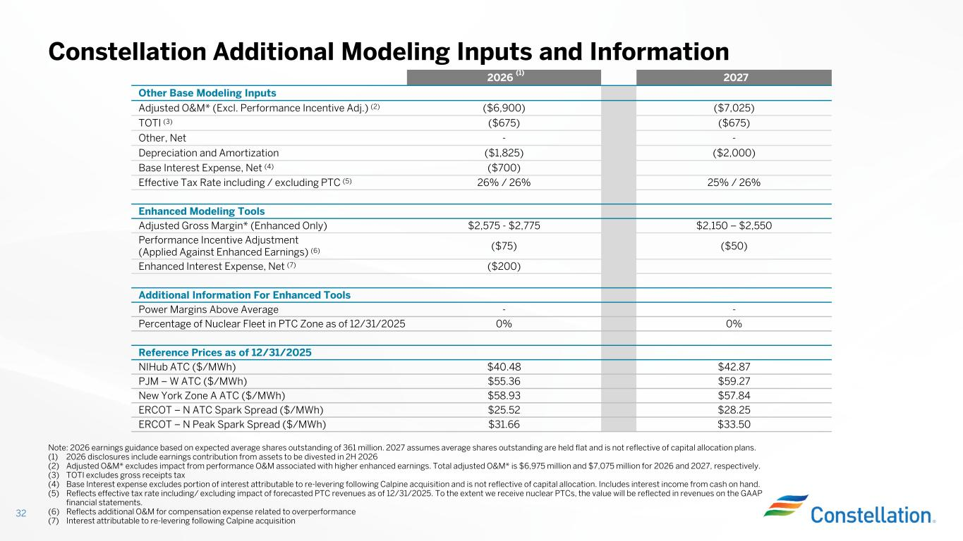
Constellation Additional Modeling Inputs and Information 32 Note: 2026 earnings guidance based on expected average shares outstanding of 361 million. 2027 assumes average shares outstanding are held flat and is not reflective of capital allocation plans. (1) 2026 disclosures include earnings contribution from assets to be divested in 2H 2026 (2) Adjusted O&M* excludes impact from performance O&M associated with higher enhanced earnings. Total adjusted O&M* is $6,975 million and $7,075 million for 2026 and 2027, respectively. (3) TOTI excludes gross receipts tax (4) Base Interest expense excludes portion of interest attributable to re-levering following Calpine acquisition and is not reflective of capital allocation. Includes interest income from cash on hand. (5) Reflects effective tax rate including/ excluding impact of forecasted PTC revenues as of 12/31/2025. To the extent we receive nuclear PTCs, the value will be reflected in revenues on the GAAP financial statements. (6) Reflects additional O&M for compensation expense related to overperformance (7) Interest attributable to re-levering following Calpine acquisition 20272026 (1) Other Base Modeling Inputs ($7,025)($6,900)Adjusted O&M* (Excl. Performance Incentive Adj.) (2) ($675)($675)TOTI (3) --Other, Net ($2,000)($1,825)Depreciation and Amortization ($700)Base Interest Expense, Net (4) 25% / 26%26% / 26%Effective Tax Rate including / excluding PTC (5) Enhanced Modeling Tools $2,150 – $2,550$2,575 - $2,775Adjusted Gross Margin* (Enhanced Only) ($50)($75) Performance Incentive Adjustment (Applied Against Enhanced Earnings) (6) ($200)Enhanced Interest Expense, Net (7) Additional Information For Enhanced Tools --Power Margins Above Average 0%0%Percentage of Nuclear Fleet in PTC Zone as of 12/31/2025 Reference Prices as of 12/31/2025 $42.87$40.48NIHub ATC ($/MWh) $59.27$55.36PJM – W ATC ($/MWh) $57.84$58.93New York Zone A ATC ($/MWh) $28.25$25.52ERCOT – N ATC Spark Spread ($/MWh) $33.50$31.66ERCOT – N Peak Spark Spread ($/MWh)

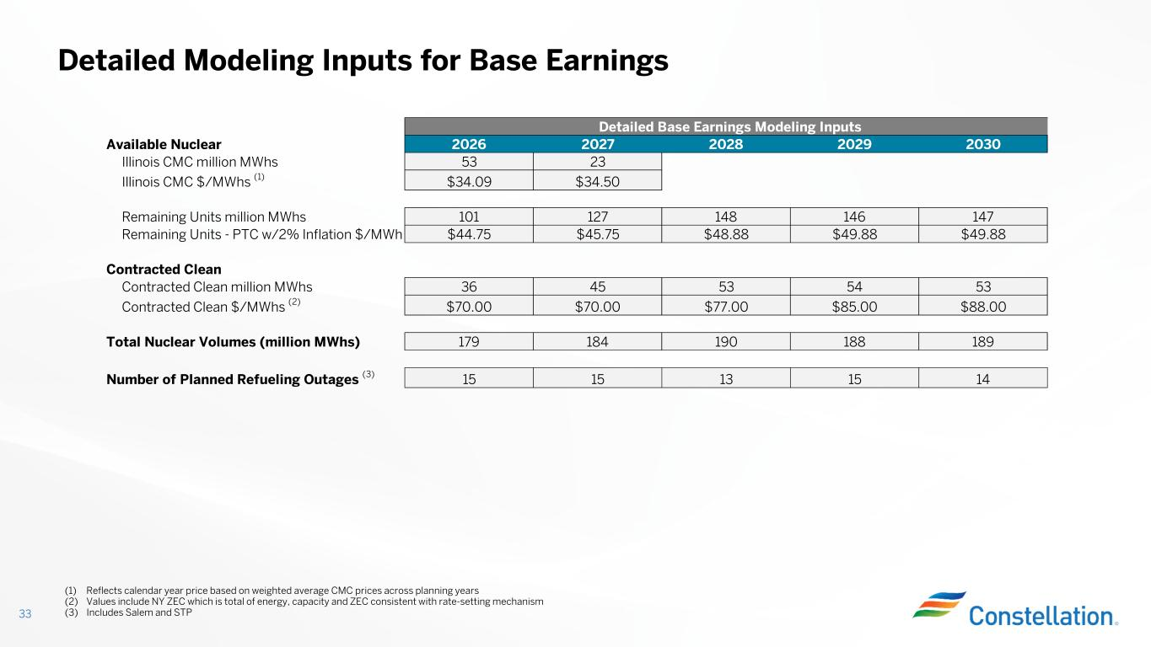
Detailed Modeling Inputs for Base Earnings 33 (1) Reflects calendar year price based on weighted average CMC prices across planning years (2) Values include NY ZEC which is total of energy, capacity and ZEC consistent with rate-setting mechanism (3) Includes Salem and STP Detailed Base Earnings Modeling Inputs Available Nuclear 2026 2027 2028 2029 2030 Illinois CMC million MWhs 53 23 Illinois CMC $/MWhs (1) $34.09 $34.50 Remaining Units million MWhs 101 127 148 146 147 Remaining Units - PTC w/2% Inflation $/MWh $44.75 $45.75 $48.88 $49.88 $49.88 Contracted Clean Contracted Clean million MWhs 36 45 53 54 53 Contracted Clean $/MWhs (2) $70.00 $70.00 $77.00 $85.00 $88.00 Total Nuclear Volumes (million MWhs) 179 184 190 188 189 Number of Planned Refueling Outages (3) 15 15 13 15 14

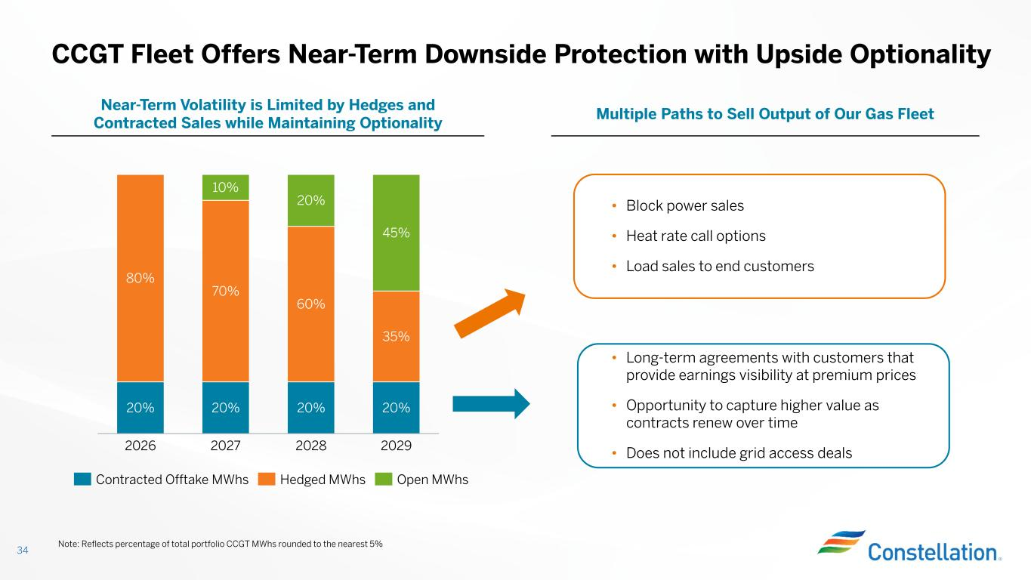
CCGT Fleet Offers Near-Term Downside Protection with Upside Optionality 34 Multiple Paths to Sell Output of Our Gas Fleet Near-Term Volatility is Limited by Hedges and Contracted Sales while Maintaining Optionality 20% 80% 2026 20% 70% 10% 2027 20% 60% 20% 2028 20% 35% 45% 2029 Contracted Offtake MWhs Hedged MWhs Open MWhs • Block power sales • Heat rate call options • Load sales to end customers • Long-term agreements with customers that provide earnings visibility at premium prices • Opportunity to capture higher value as contracts renew over time • Does not include grid access deals Note: Reflects percentage of total portfolio CCGT MWhs rounded to the nearest 5%

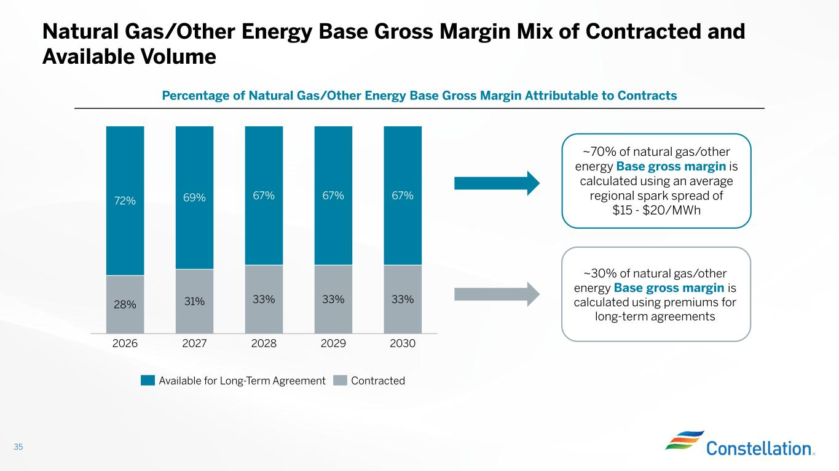
Natural Gas/Other Energy Base Gross Margin Mix of Contracted and Available Volume 35 Percentage of Natural Gas/Other Energy Base Gross Margin Attributable to Contracts 28% 72% 2026 31% 69% 2027 33% 67% 2028 33% 67% 2029 33% 67% 2030 Available for Long-Term Agreement Contracted ~70% of natural gas/other energy Base gross margin is calculated using an average regional spark spread of $15 - $20/MWh ~30% of natural gas/other energy Base gross margin is calculated using premiums for long-term agreements

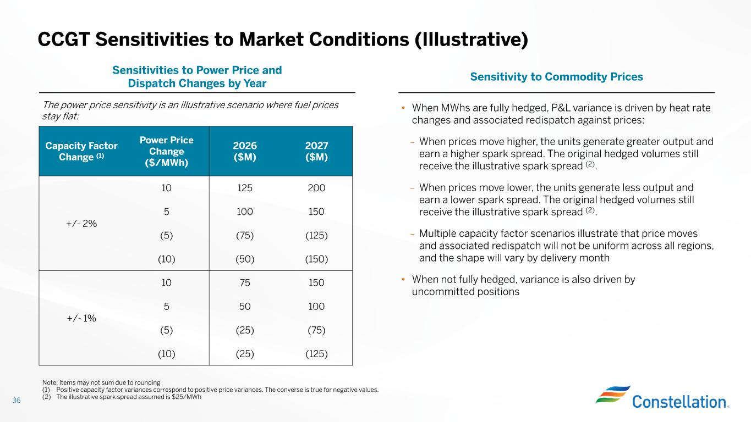
CCGT Sensitivities to Market Conditions (Illustrative) 36 Sensitivity to Commodity Prices Sensitivities to Power Price and Dispatch Changes by Year 2027 ($M) 2026 ($M) Power Price Change ($/MWh) Capacity Factor Change (1) 20012510 +/- 2% 1501005 (125)(75)(5) (150)(50)(10) 1507510 +/- 1% 10050 5 (75)(25)(5) (125)(25)(10) • When MWhs are fully hedged, P&L variance is driven by heat rate changes and associated redispatch against prices: – When prices move higher, the units generate greater output and earn a higher spark spread. The original hedged volumes still receive the illustrative spark spread (2). – When prices move lower, the units generate less output and earn a lower spark spread. The original hedged volumes still receive the illustrative spark spread (2). – Multiple capacity factor scenarios illustrate that price moves and associated redispatch will not be uniform across all regions, and the shape will vary by delivery month • When not fully hedged, variance is also driven by uncommitted positions Note: Items may not sum due to rounding (1) Positive capacity factor variances correspond to positive price variances. The converse is true for negative values. (2) The illustrative spark spread assumed is $25/MWh The power price sensitivity is an illustrative scenario where fuel prices stay flat:

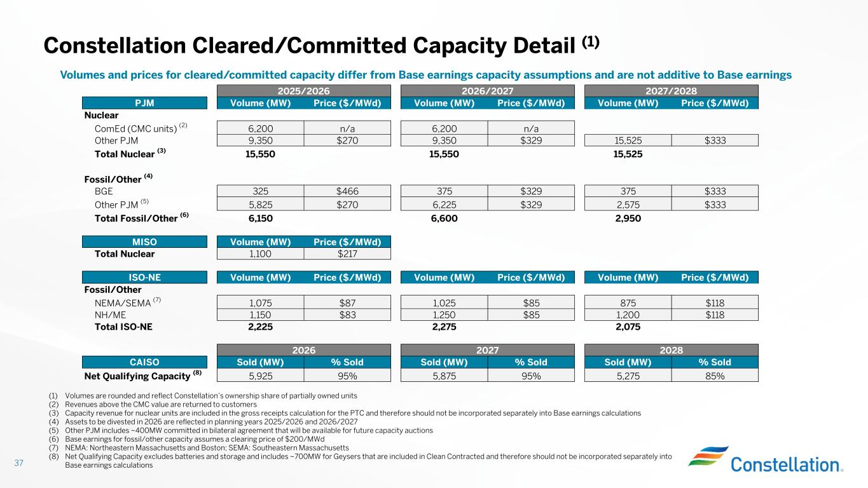
Constellation Cleared/Committed Capacity Detail (1) 37 (1) Volumes are rounded and reflect Constellation’s ownership share of partially owned units (2) Revenues above the CMC value are returned to customers (3) Capacity revenue for nuclear units are included in the gross receipts calculation for the PTC and therefore should not be incorporated separately into Base earnings calculations (4) Assets to be divested in 2026 are reflected in planning years 2025/2026 and 2026/2027 (5) Other PJM includes ~400MW committed in bilateral agreement that will be available for future capacity auctions (6) Base earnings for fossil/other capacity assumes a clearing price of $200/MWd (7) NEMA: Northeastern Massachusetts and Boston; SEMA: Southeastern Massachusetts (8) Net Qualifying Capacity excludes batteries and storage and includes ~700MW for Geysers that are included in Clean Contracted and therefore should not be incorporated separately into Base earnings calculations Volumes and prices for cleared/committed capacity differ from Base earnings capacity assumptions and are not additive to Base earnings PJM Volume (MW) Price ($/MWd) Volume (MW) Price ($/MWd) Volume (MW) Price ($/MWd) Nuclear ComEd (CMC units) (2) 6,200 n/a 6,200 n/a Other PJM 9,350 $270 9,350 $329 15,525 $333 Total Nuclear (3) 15,550 15,550 15,525 Fossil/Other (4) BGE 325 $466 375 $329 375 $333 Other PJM (5) 5,825 $270 6,225 $329 2,575 $333 Total Fossil/Other (6) 6,150 6,600 2,950 MISO Volume (MW) Price ($/MWd) Total Nuclear 1,100 $217 ISO-NE Volume (MW) Price ($/MWd) Volume (MW) Price ($/MWd) Volume (MW) Price ($/MWd) Fossil/Other NEMA/SEMA (7) 1,075 $87 1,025 $85 875 $118 NH/ME 1,150 $83 1,250 $85 1,200 $118 Total ISO-NE 2,225 2,275 2,075 CAISO Sold (MW) % Sold Sold (MW) % Sold Sold (MW) % Sold Net Qualifying Capacity (8) 5,925 95% 5,875 95% 5,275 85% 2025/2026 2026/2027 2027/2028 2026 2027 2028

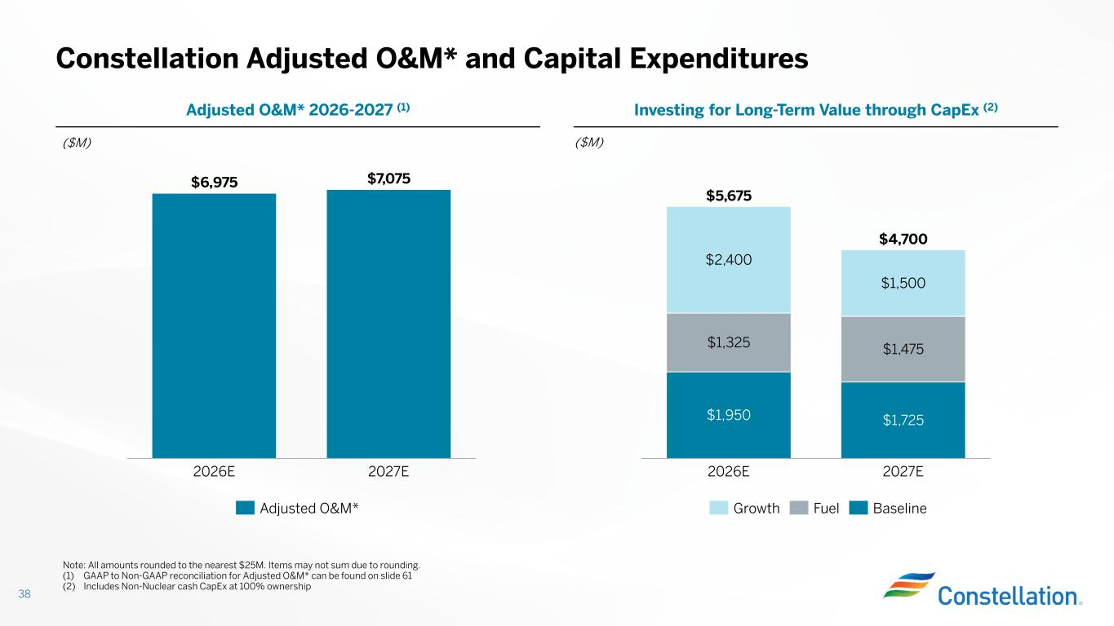
Constellation Adjusted O&M* and Capital Expenditures 38 ($M) Note: All amounts rounded to the nearest $25M. Items may not sum due to rounding. (1) GAAP to Non-GAAP reconciliation for Adjusted O&M* can be found on slide 61 (2) Includes Non-Nuclear cash CapEx at 100% ownership Investing for Long-Term Value through CapEx (2)Adjusted O&M* 2026-2027 (1) ($M) $1,950 $1,725 $1,325 $1,475 $2,400 $1,500 2026E 2027E $5,675 $4,700 Growth Fuel Baseline $6,975 $7,075 2026E 2027E Adjusted O&M*

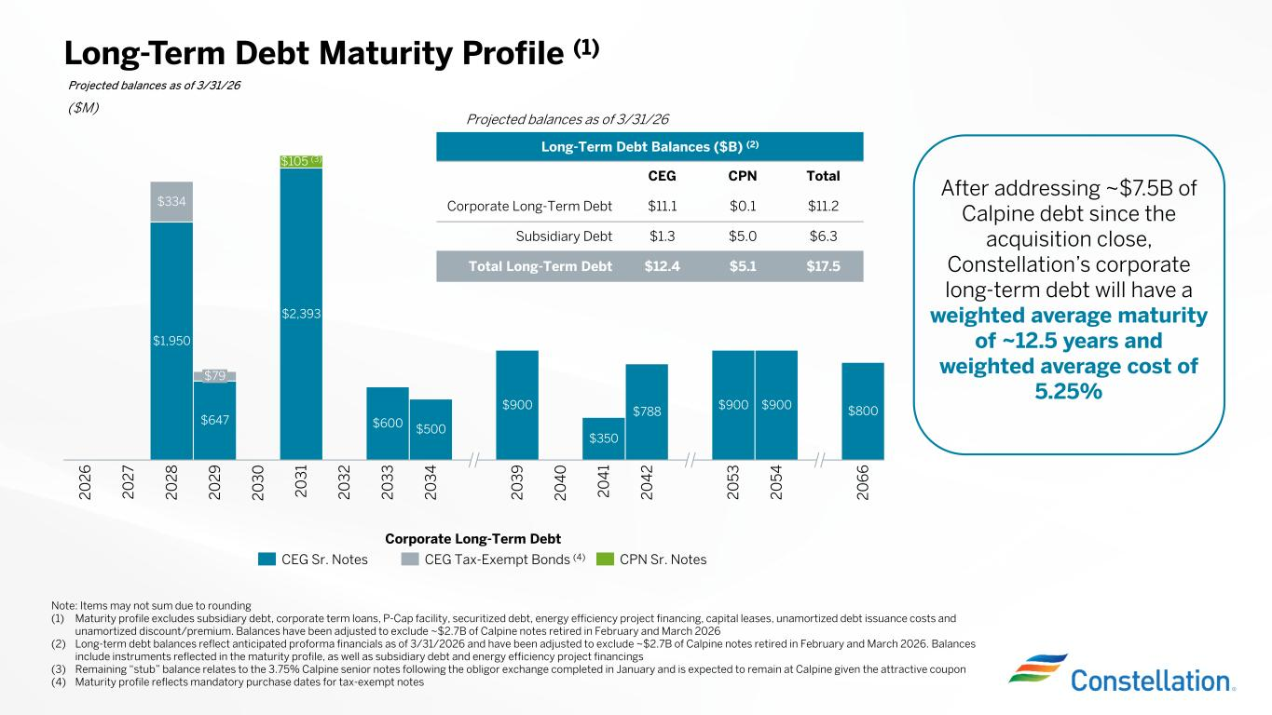
($M) CEG Sr. Notes CEG Tax-Exempt Bonds (4) CPN Sr. Notes Long-Term Debt Maturity Profile (1) Corporate Long-Term Debt Projected balances as of 3/31/26 Note: Items may not sum due to rounding (1) Maturity profile excludes subsidiary debt, corporate term loans, P-Cap facility, securitized debt, energy efficiency project financing, capital leases, unamortized debt issuance costs and unamortized discount/premium. Balances have been adjusted to exclude ~$2.7B of Calpine notes retired in February and March 2026 (2) Long-term debt balances reflect anticipated proforma financials as of 3/31/2026 and have been adjusted to exclude ~$2.7B of Calpine notes retired in February and March 2026. Balances include instruments reflected in the maturity profile, as well as subsidiary debt and energy efficiency project financings (3) Remaining “stub” balance relates to the 3.75% Calpine senior notes following the obligor exchange completed in January and is expected to remain at Calpine given the attractive coupon (4) Maturity profile reflects mandatory purchase dates for tax-exempt notes $1,950 $647 $2,393 $600 $500 $900 $350 $788 $900 $900 $800 $334 2 0 2 6 2 0 2 7 2 0 2 8 $79 2 0 2 9 2 0 3 0 $105 (3) 2 0 3 1 2 0 3 2 2 0 3 3 2 0 3 4 2 0 3 9 2 0 4 0 2 0 4 1 2 0 4 2 2 0 5 3 2 0 5 4 2 0 6 6 Long-Term Debt Balances ($B) (2) TotalCPNCEG $11.2$0.1$11.1Corporate Long-Term Debt $6.3$5.0$1.3Subsidiary Debt $17.5$5.1$12.4Total Long-Term Debt Projected balances as of 3/31/26 After addressing ~$7.5B of Calpine debt since the acquisition close, Constellation’s corporate long-term debt will have a weighted average maturity of ~12.5 years and weighted average cost of 5.25%

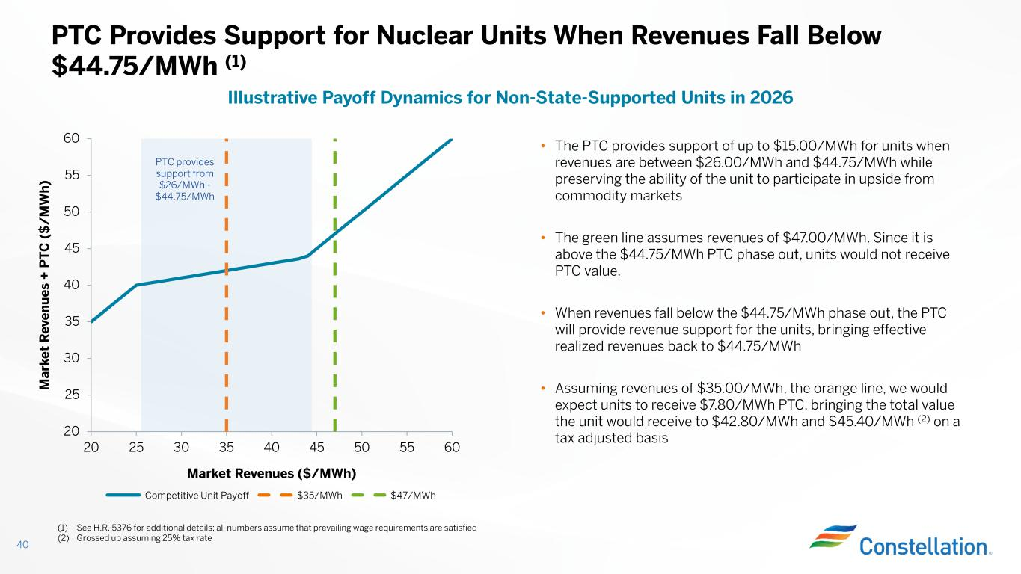
20 25 30 35 40 45 50 55 60 20 25 30 35 40 45 50 55 60 Market Revenues ($/MWh) M ar ke t R ev en u es + P T C ( $ / M W h ) 40 PTC Provides Support for Nuclear Units When Revenues Fall Below $44.75/MWh (1) Illustrative Payoff Dynamics for Non-State-Supported Units in 2026 • The PTC provides support of up to $15.00/MWh for units when revenues are between $26.00/MWh and $44.75/MWh while preserving the ability of the unit to participate in upside from commodity markets • The green line assumes revenues of $47.00/MWh. Since it is above the $44.75/MWh PTC phase out, units would not receive PTC value. • When revenues fall below the $44.75/MWh phase out, the PTC will provide revenue support for the units, bringing effective realized revenues back to $44.75/MWh • Assuming revenues of $35.00/MWh, the orange line, we would expect units to receive $7.80/MWh PTC, bringing the total value the unit would receive to $42.80/MWh and $45.40/MWh (2) on a tax adjusted basis Competitive Unit Payoff $35/MWh $47/MWh PTC provides support from $26/MWh - $44.75/MWh (1) See H.R. 5376 for additional details; all numbers assume that prevailing wage requirements are satisfied (2) Grossed up assuming 25% tax rate

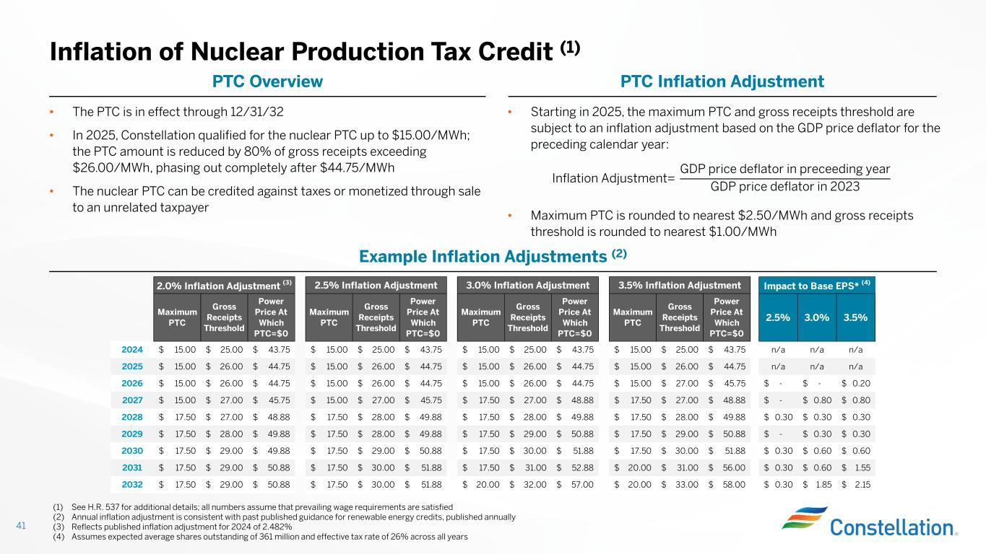
• Starting in 2025, the maximum PTC and gross receipts threshold are subject to an inflation adjustment based on the GDP price deflator for the preceding calendar year: • Maximum PTC is rounded to nearest $2.50/MWh and gross receipts threshold is rounded to nearest $1.00/MWh Inflation of Nuclear Production Tax Credit (1) 41 (1) See H.R. 537 for additional details; all numbers assume that prevailing wage requirements are satisfied (2) Annual inflation adjustment is consistent with past published guidance for renewable energy credits, published annually (3) Reflects published inflation adjustment for 2024 of 2.482% (4) Assumes expected average shares outstanding of 361 million and effective tax rate of 26% across all years PTC Inflation AdjustmentPTC Overview Inflation Adjustment= GDP price deflator in preceeding year GDP price deflator in 2023 • The PTC is in effect through 12/31/32 • In 2025, Constellation qualified for the nuclear PTC up to $15.00/MWh; the PTC amount is reduced by 80% of gross receipts exceeding $26.00/MWh, phasing out completely after $44.75/MWh • The nuclear PTC can be credited against taxes or monetized through sale to an unrelated taxpayer Example Inflation Adjustments (2) Maximum PTC Gross Receipts Threshold Power Price At Which PTC=$0 Maximum PTC Gross Receipts Threshold Power Price At Which PTC=$0 Maximum PTC Gross Receipts Threshold Power Price At Which PTC=$0 Maximum PTC Gross Receipts Threshold Power Price At Which PTC=$0 2.5% 3.0% 3.5% 2024 15.00$ 25.00$ 43.75$ 15.00$ 25.00$ 43.75$ 15.00$ 25.00$ 43.75$ 15.00$ 25.00$ 43.75$ n/a n/a n/a 2025 15.00$ 26.00$ 44.75$ 15.00$ 26.00$ 44.75$ 15.00$ 26.00$ 44.75$ 15.00$ 26.00$ 44.75$ n/a n/a n/a 2026 15.00$ 26.00$ 44.75$ 15.00$ 26.00$ 44.75$ 15.00$ 26.00$ 44.75$ 15.00$ 27.00$ 45.75$ -$ -$ 0.20$ 2027 15.00$ 27.00$ 45.75$ 15.00$ 27.00$ 45.75$ 17.50$ 27.00$ 48.88$ 17.50$ 27.00$ 48.88$ -$ 0.80$ 0.80$ 2028 17.50$ 27.00$ 48.88$ 17.50$ 28.00$ 49.88$ 17.50$ 28.00$ 49.88$ 17.50$ 28.00$ 49.88$ 0.30$ 0.30$ 0.30$ 2029 17.50$ 28.00$ 49.88$ 17.50$ 28.00$ 49.88$ 17.50$ 29.00$ 50.88$ 17.50$ 29.00$ 50.88$ -$ 0.30$ 0.30$ 2030 17.50$ 29.00$ 49.88$ 17.50$ 29.00$ 50.88$ 17.50$ 30.00$ 51.88$ 17.50$ 30.00$ 51.88$ 0.30$ 0.60$ 0.60$ 2031 17.50$ 29.00$ 50.88$ 17.50$ 30.00$ 51.88$ 17.50$ 31.00$ 52.88$ 20.00$ 31.00$ 56.00$ 0.30$ 0.60$ 1.55$ 2032 17.50$ 29.00$ 50.88$ 17.50$ 30.00$ 51.88$ 20.00$ 32.00$ 57.00$ 20.00$ 33.00$ 58.00$ 0.30$ 1.85$ 2.15$ 2.0% Inflation Adjustment (3) 2.5% Inflation Adjustment 3.5% Inflation Adjustment3.0% Inflation Adjustment Impact to Base EPS* (4)

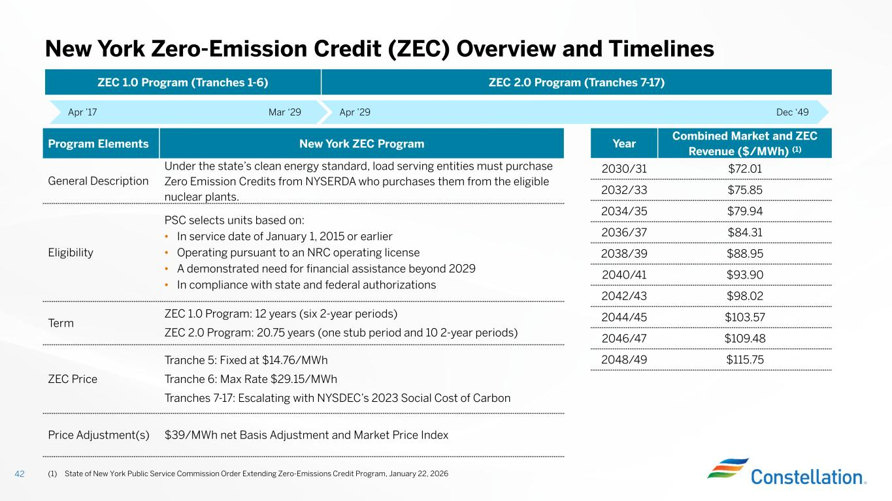
New York Zero-Emission Credit (ZEC) Overview and Timelines 42 Apr ’17 Mar ‘29 New York ZEC ProgramProgram Elements Under the state’s clean energy standard, load serving entities must purchase Zero Emission Credits from NYSERDA who purchases them from the eligible nuclear plants. General Description PSC selects units based on: • In service date of January 1, 2015 or earlier • Operating pursuant to an NRC operating license • A demonstrated need for financial assistance beyond 2029 • In compliance with state and federal authorizations Eligibility ZEC 1.0 Program: 12 years (six 2-year periods) ZEC 2.0 Program: 20.75 years (one stub period and 10 2-year periods) Term Tranche 5: Fixed at $14.76/MWh Tranche 6: Max Rate $29.15/MWh Tranches 7-17: Escalating with NYSDEC’s 2023 Social Cost of Carbon ZEC Price $39/MWh net Basis Adjustment and Market Price IndexPrice Adjustment(s) December ‘49Apr ’29 Dec ‘49 ZEC 2.0 Program (Tranches 7-17)ZEC 1.0 Program (Tranches 1-6) Combined Market and ZEC Revenue ($/MWh) (1) Year $72.012030/31 $75.852032/33 $79.942034/35 $84.312036/37 $88.952038/39 $93.902040/41 $98.022042/43 $103.572044/45 $109.482046/47 $115.752048/49 (1) State of New York Public Service Commission Order Extending Zero-Emissions Credit Program, January 22, 2026

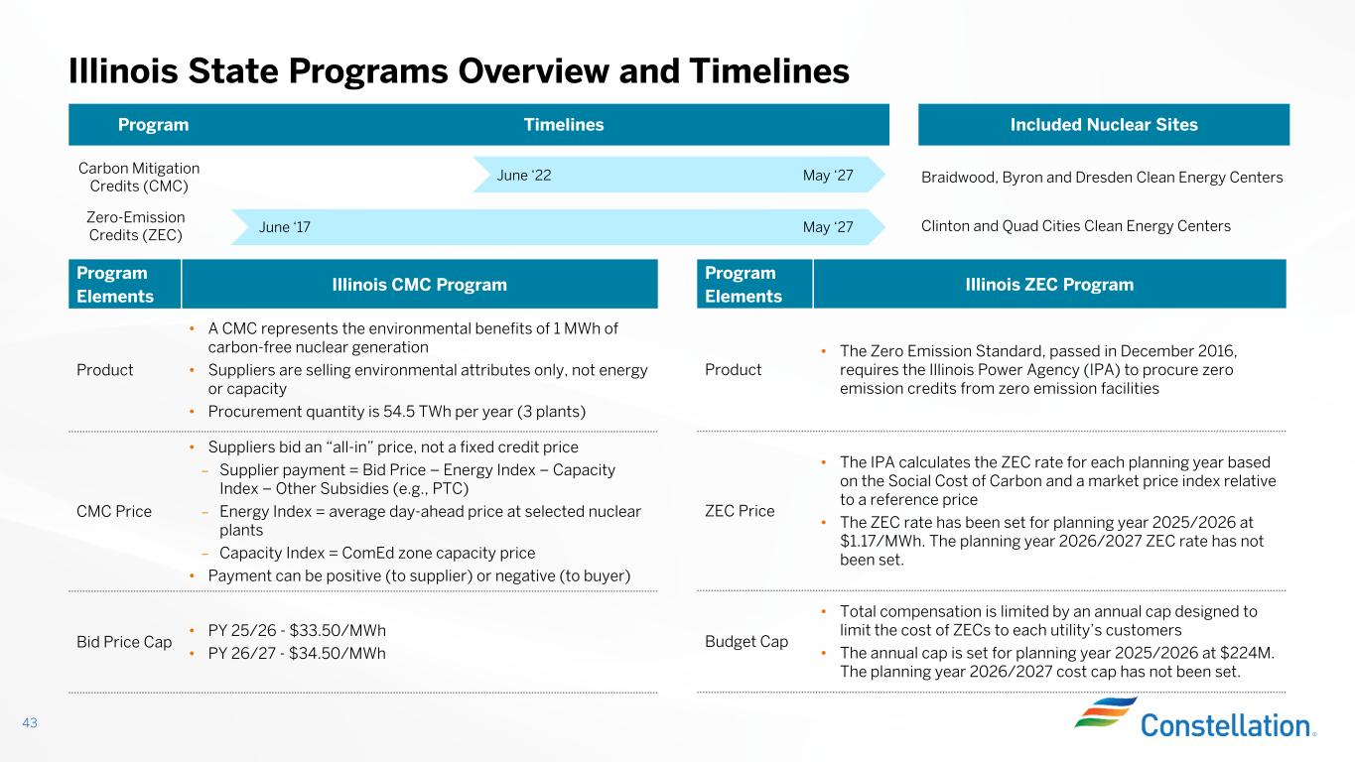
43 Illinois State Programs Overview and Timelines Illinois CMC Program Program Elements • A CMC represents the environmental benefits of 1 MWh of carbon-free nuclear generation • Suppliers are selling environmental attributes only, not energy or capacity • Procurement quantity is 54.5 TWh per year (3 plants) Product • Suppliers bid an “all-in” price, not a fixed credit price – Supplier payment = Bid Price – Energy Index – Capacity Index – Other Subsidies (e.g., PTC) – Energy Index = average day-ahead price at selected nuclear plants – Capacity Index = ComEd zone capacity price • Payment can be positive (to supplier) or negative (to buyer) CMC Price • PY 25/26 - $33.50/MWh • PY 26/27 - $34.50/MWh Bid Price Cap Illinois ZEC Program Program Elements • The Zero Emission Standard, passed in December 2016, requires the Illinois Power Agency (IPA) to procure zero emission credits from zero emission facilities Product • The IPA calculates the ZEC rate for each planning year based on the Social Cost of Carbon and a market price index relative to a reference price • The ZEC rate has been set for planning year 2025/2026 at $1.17/MWh. The planning year 2026/2027 ZEC rate has not been set. ZEC Price • Total compensation is limited by an annual cap designed to limit the cost of ZECs to each utility’s customers • The annual cap is set for planning year 2025/2026 at $224M. The planning year 2026/2027 cost cap has not been set. Budget Cap Included Nuclear SitesTimelinesProgram Carbon Mitigation Credits (CMC) June ‘22 May ‘27 June ‘17 May ‘27 Braidwood, Byron and Dresden Clean Energy Centers Clinton and Quad Cities Clean Energy Centers Zero-Emission Credits (ZEC)

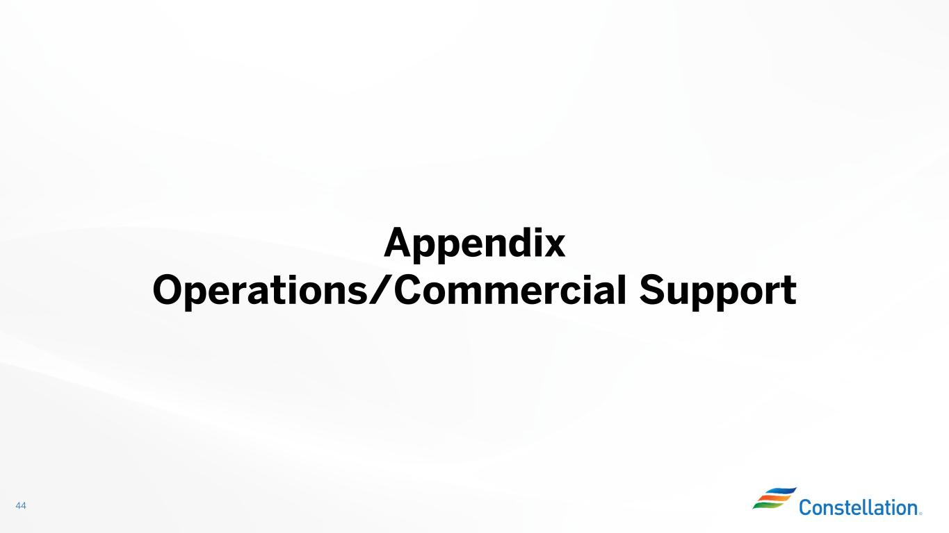
44 Appendix Operations/Commercial Support

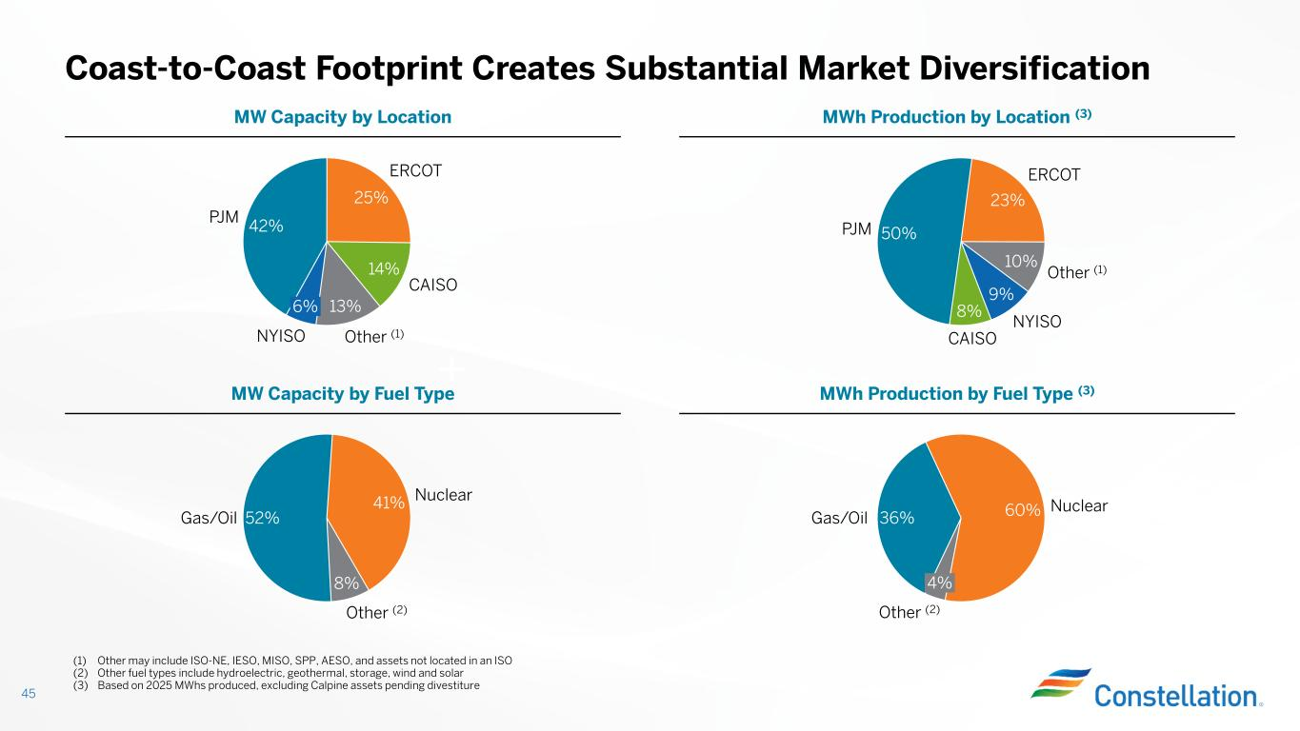
Coast-to-Coast Footprint Creates Substantial Market Diversification 45 (1) Other may include ISO-NE, IESO, MISO, SPP, AESO, and assets not located in an ISO (2) Other fuel types include hydroelectric, geothermal, storage, wind and solar (3) Based on 2025 MWhs produced, excluding Calpine assets pending divestiture 50% 23% 10% 9% 8% PJM ERCOT Other (1) NYISO CAISO 42% 25% 14% 13% PJM ERCOT CAISO Other (1) 6% NYISO 52% 41% 8% Gas/Oil Nuclear Other (2) MWh Production by Location (3)MW Capacity by Location 60%36% Nuclear 4% Other (2) Gas/Oil MWh Production by Fuel Type (3)MW Capacity by Fuel Type

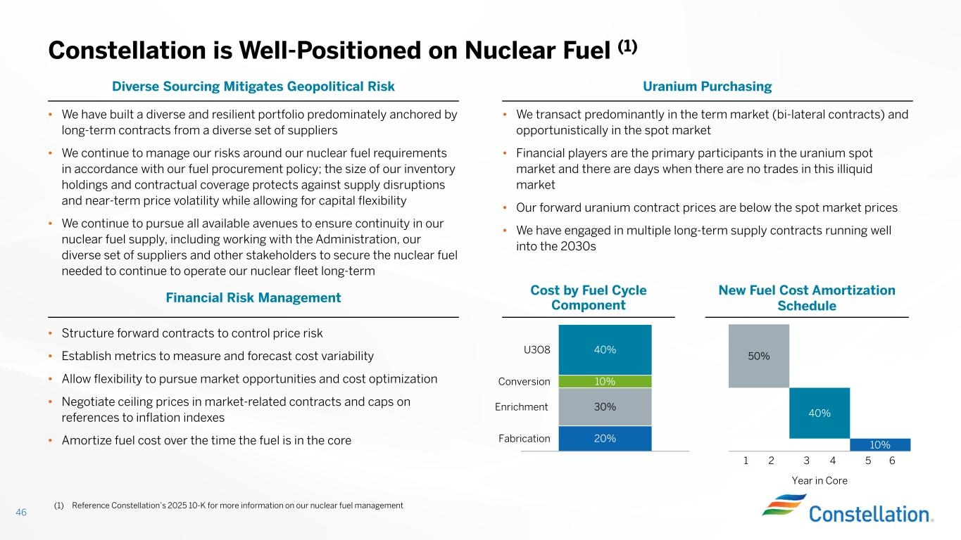
• We have built a diverse and resilient portfolio predominately anchored by long-term contracts from a diverse set of suppliers • We continue to manage our risks around our nuclear fuel requirements in accordance with our fuel procurement policy; the size of our inventory holdings and contractual coverage protects against supply disruptions and near-term price volatility while allowing for capital flexibility • We continue to pursue all available avenues to ensure continuity in our nuclear fuel supply, including working with the Administration, our diverse set of suppliers and other stakeholders to secure the nuclear fuel needed to continue to operate our nuclear fleet long-term • We transact predominantly in the term market (bi-lateral contracts) and opportunistically in the spot market • Financial players are the primary participants in the uranium spot market and there are days when there are no trades in this illiquid market • Our forward uranium contract prices are below the spot market prices • We have engaged in multiple long-term supply contracts running well into the 2030s Constellation is Well-Positioned on Nuclear Fuel (1) Uranium PurchasingDiverse Sourcing Mitigates Geopolitical Risk 20% 30% 10% 40%U3O8 Conversion Enrichment Fabrication 10% 40% 50% Year in Core 1 2 3 4 5 6 New Fuel Cost Amortization Schedule Cost by Fuel Cycle ComponentFinancial Risk Management 46 • Structure forward contracts to control price risk • Establish metrics to measure and forecast cost variability • Allow flexibility to pursue market opportunities and cost optimization • Negotiate ceiling prices in market-related contracts and caps on references to inflation indexes • Amortize fuel cost over the time the fuel is in the core (1) Reference Constellation’s 2025 10-K for more information on our nuclear fuel management

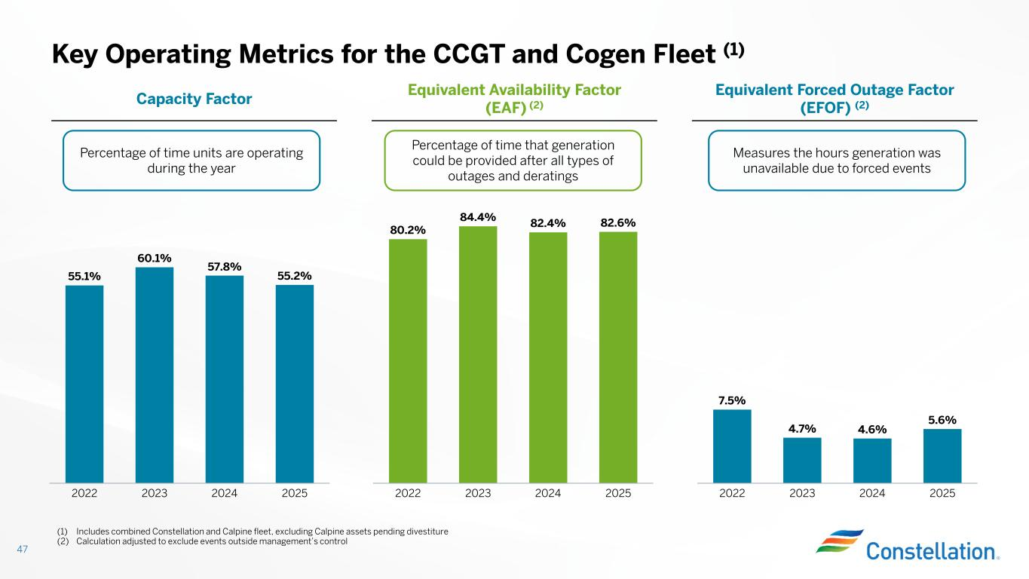
Key Operating Metrics for the CCGT and Cogen Fleet (1) 47 55.1% 60.1% 57.8% 55.2% 2022 2023 2024 2025 Equivalent Forced Outage Factor (EFOF) (2) Equivalent Availability Factor (EAF) (2)Capacity Factor 7.5% 4.7% 4.6% 5.6% 2022 2023 2024 2025 80.2% 84.4% 82.4% 82.6% 2022 2023 2024 2025 Percentage of time units are operating during the year Percentage of time that generation could be provided after all types of outages and deratings Measures the hours generation was unavailable due to forced events (1) Includes combined Constellation and Calpine fleet, excluding Calpine assets pending divestiture (2) Calculation adjusted to exclude events outside management’s control

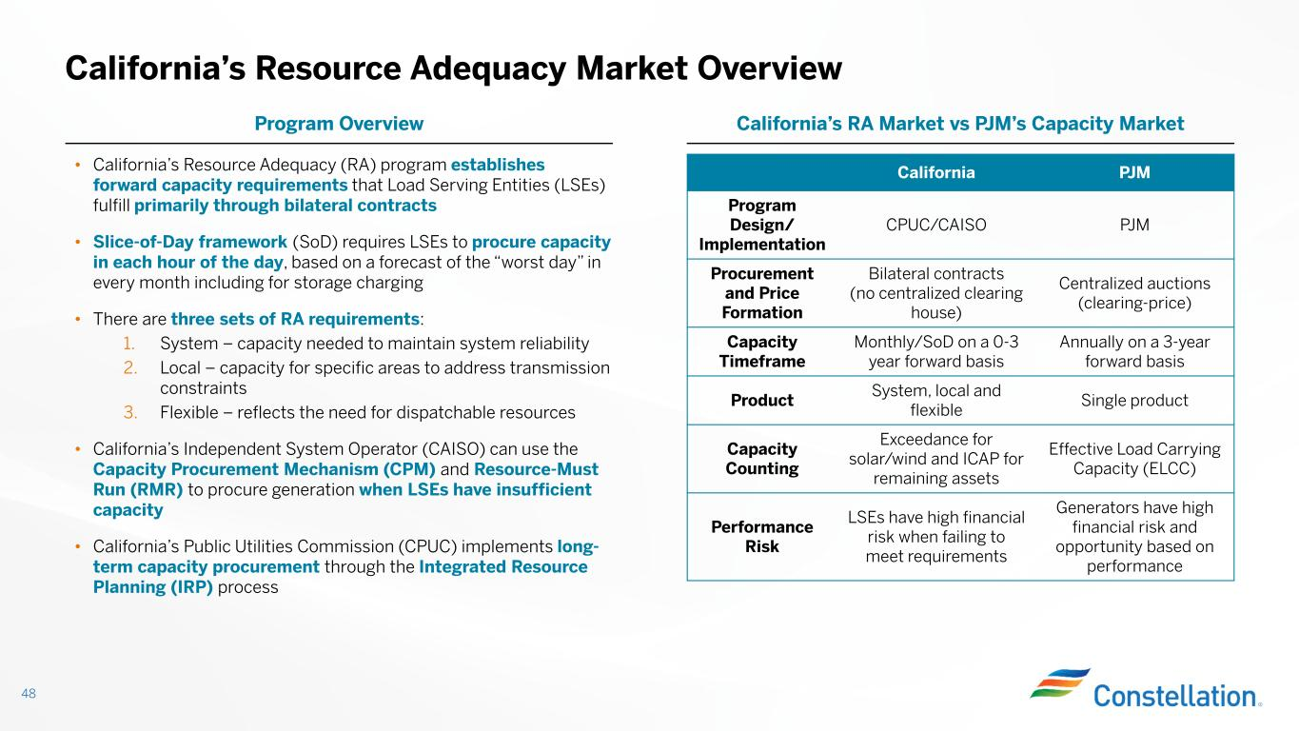
California’s Resource Adequacy Market Overview 48 • California’s Resource Adequacy (RA) program establishes forward capacity requirements that Load Serving Entities (LSEs) fulfill primarily through bilateral contracts • Slice-of-Day framework (SoD) requires LSEs to procure capacity in each hour of the day, based on a forecast of the “worst day” in every month including for storage charging • There are three sets of RA requirements: 1. System – capacity needed to maintain system reliability 2. Local – capacity for specific areas to address transmission constraints 3. Flexible – reflects the need for dispatchable resources • California’s Independent System Operator (CAISO) can use the Capacity Procurement Mechanism (CPM) and Resource-Must Run (RMR) to procure generation when LSEs have insufficient capacity • California’s Public Utilities Commission (CPUC) implements long- term capacity procurement through the Integrated Resource Planning (IRP) process California’s RA Market vs PJM’s Capacity MarketProgram Overview PJMCalifornia PJMCPUC/CAISO Program Design/ Implementation Centralized auctions (clearing-price) Bilateral contracts (no centralized clearing house) Procurement and Price Formation Annually on a 3-year forward basis Monthly/SoD on a 0-3 year forward basis Capacity Timeframe Single product System, local and flexible Product Effective Load Carrying Capacity (ELCC) Exceedance for solar/wind and ICAP for remaining assets Capacity Counting Generators have high financial risk and opportunity based on performance LSEs have high financial risk when failing to meet requirements Performance Risk

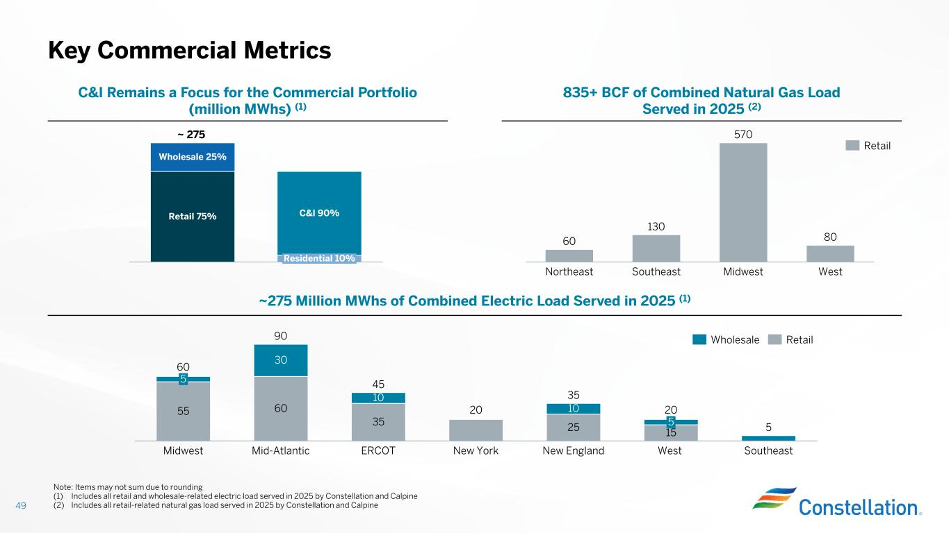
49 Key Commercial Metrics 60 130 570 80 Northeast Southeast Midwest West Retail 835+ BCF of Combined Natural Gas Load Served in 2025 (2) C&I Remains a Focus for the Commercial Portfolio (million MWhs) (1) Wholesale 25% Retail 75% C&I 90% Residential 10% ~ 275 Note: Items may not sum due to rounding (1) Includes all retail and wholesale-related electric load served in 2025 by Constellation and Calpine (2) Includes all retail-related natural gas load served in 2025 by Constellation and Calpine 55 60 35 20 25 15 30 10 10 5 Midwest Mid-Atlantic ERCOT New York New England 5 West Southeast 60 90 45 35 20 5 Wholesale Retail ~275 Million MWhs of Combined Electric Load Served in 2025 (1)

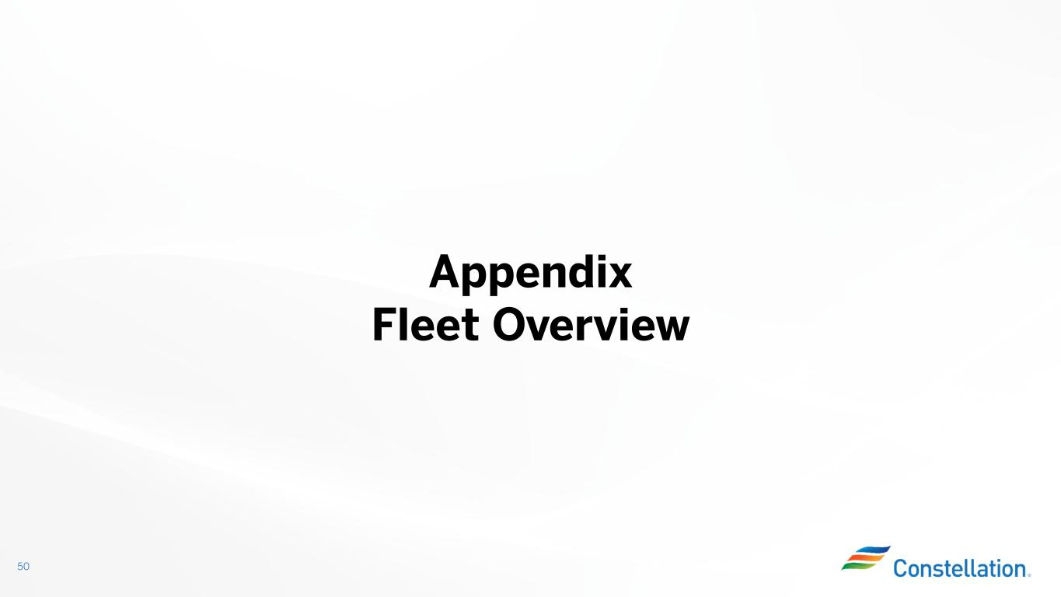
50 Appendix Fleet Overview

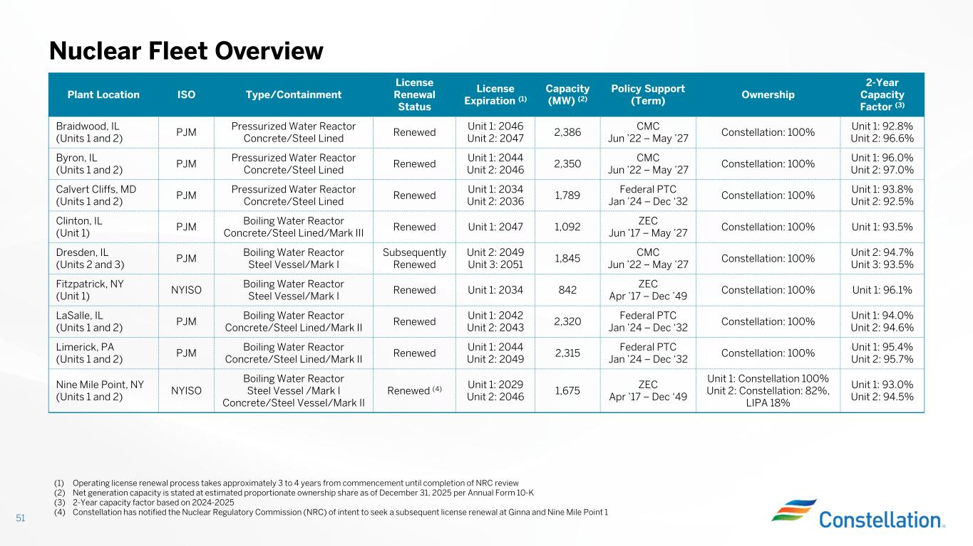
Nuclear Fleet Overview 51 2-Year Capacity Factor (3) Ownership Policy Support (Term) Capacity (MW) (2) License Expiration (1) License Renewal Status Type/ContainmentISOPlant Location Unit 1: 92.8% Unit 2: 96.6% Constellation: 100% CMC Jun ’22 – May ’27 2,386 Unit 1: 2046 Unit 2: 2047 Renewed Pressurized Water Reactor Concrete/Steel Lined PJM Braidwood, IL (Units 1 and 2) Unit 1: 96.0% Unit 2: 97.0% Constellation: 100% CMC Jun ’22 – May ’27 2,350 Unit 1: 2044 Unit 2: 2046 Renewed Pressurized Water Reactor Concrete/Steel Lined PJM Byron, IL (Units 1 and 2) Unit 1: 93.8% Unit 2: 92.5% Constellation: 100% Federal PTC Jan ’24 – Dec ‘32 1,789 Unit 1: 2034 Unit 2: 2036 Renewed Pressurized Water Reactor Concrete/Steel Lined PJM Calvert Cliffs, MD (Units 1 and 2) Unit 1: 93.5%Constellation: 100% ZEC Jun ’17 – May ’27 1,092Unit 1: 2047Renewed Boiling Water Reactor Concrete/Steel Lined/Mark III PJM Clinton, IL (Unit 1) Unit 2: 94.7% Unit 3: 93.5% Constellation: 100% CMC Jun ’22 – May ’27 1,845 Unit 2: 2049 Unit 3: 2051 Subsequently Renewed Boiling Water Reactor Steel Vessel/Mark I PJM Dresden, IL (Units 2 and 3) Unit 1: 96.1%Constellation: 100% ZEC Apr ’17 – Dec ’49 842Unit 1: 2034Renewed Boiling Water Reactor Steel Vessel/Mark I NYISO Fitzpatrick, NY (Unit 1) Unit 1: 94.0% Unit 2: 94.6% Constellation: 100% Federal PTC Jan ’24 – Dec ‘32 2,320 Unit 1: 2042 Unit 2: 2043 Renewed Boiling Water Reactor Concrete/Steel Lined/Mark II PJM LaSalle, IL (Units 1 and 2) Unit 1: 95.4% Unit 2: 95.7% Constellation: 100% Federal PTC Jan ’24 – Dec ‘32 2,315 Unit 1: 2044 Unit 2: 2049 Renewed Boiling Water Reactor Concrete/Steel Lined/Mark II PJM Limerick, PA (Units 1 and 2) Unit 1: 93.0% Unit 2: 94.5% Unit 1: Constellation 100% Unit 2: Constellation: 82%, LIPA 18% ZEC Apr ’17 – Dec ‘49 1,675 Unit 1: 2029 Unit 2: 2046 Renewed (4) Boiling Water Reactor Steel Vessel /Mark I Concrete/Steel Vessel/Mark II NYISO Nine Mile Point, NY (Units 1 and 2) (1) Operating license renewal process takes approximately 3 to 4 years from commencement until completion of NRC review (2) Net generation capacity is stated at estimated proportionate ownership share as of December 31, 2025 per Annual Form 10-K (3) 2-Year capacity factor based on 2024-2025 (4) Constellation has notified the Nuclear Regulatory Commission (NRC) of intent to seek a subsequent license renewal at Ginna and Nine Mile Point 1

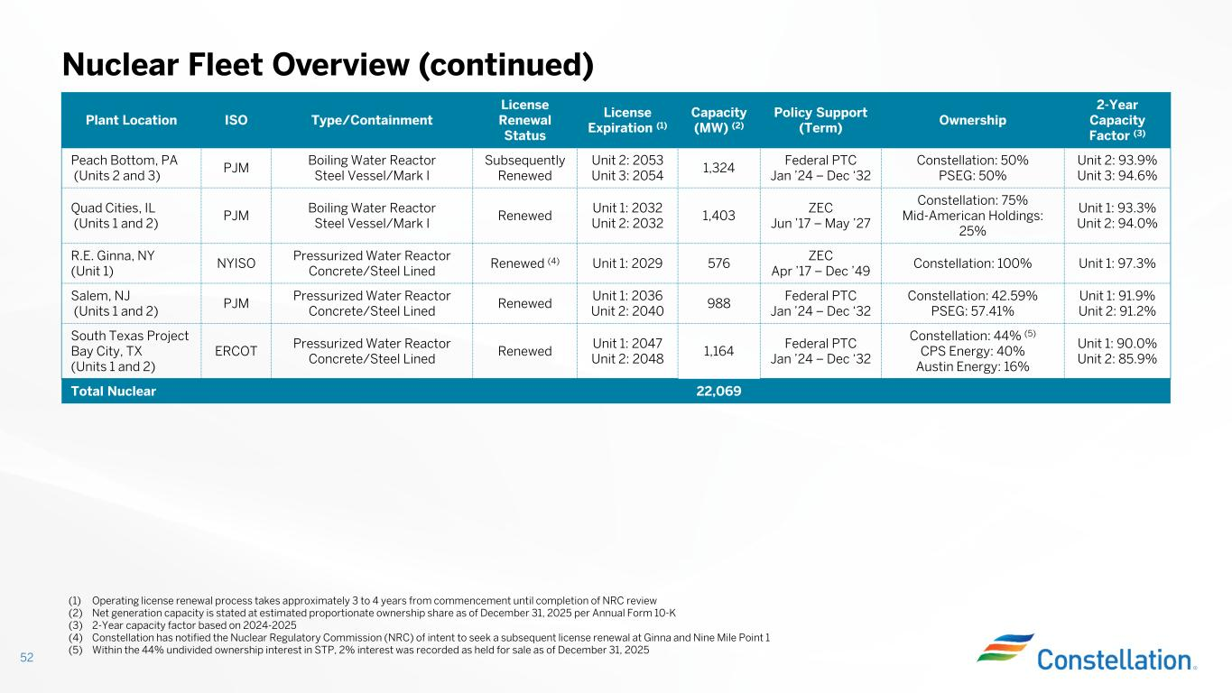
Nuclear Fleet Overview (continued) 52 2-Year Capacity Factor (3) Ownership Policy Support (Term) Capacity (MW) (2) License Expiration (1) License Renewal Status Type/ContainmentISOPlant Location Unit 2: 93.9% Unit 3: 94.6% Constellation: 50% PSEG: 50% Federal PTC Jan ’24 – Dec ‘32 1,324 Unit 2: 2053 Unit 3: 2054 Subsequently Renewed Boiling Water Reactor Steel Vessel/Mark I PJM Peach Bottom, PA (Units 2 and 3) Unit 1: 93.3% Unit 2: 94.0% Constellation: 75% Mid-American Holdings: 25% ZEC Jun ’17 – May ’27 1,403 Unit 1: 2032 Unit 2: 2032 Renewed Boiling Water Reactor Steel Vessel/Mark I PJM Quad Cities, IL (Units 1 and 2) Unit 1: 97.3%Constellation: 100% ZEC Apr ’17 – Dec ’49 576Unit 1: 2029Renewed (4)Pressurized Water Reactor Concrete/Steel Lined NYISO R.E. Ginna, NY (Unit 1) Unit 1: 91.9% Unit 2: 91.2% Constellation: 42.59% PSEG: 57.41% Federal PTC Jan ’24 – Dec ‘32 988 Unit 1: 2036 Unit 2: 2040 Renewed Pressurized Water Reactor Concrete/Steel Lined PJM Salem, NJ (Units 1 and 2) Unit 1: 90.0% Unit 2: 85.9% Constellation: 44% (5) CPS Energy: 40% Austin Energy: 16% Federal PTC Jan ’24 – Dec ‘32 1,164 Unit 1: 2047 Unit 2: 2048 Renewed Pressurized Water Reactor Concrete/Steel Lined ERCOT South Texas Project Bay City, TX (Units 1 and 2) 22,069Total Nuclear (1) Operating license renewal process takes approximately 3 to 4 years from commencement until completion of NRC review (2) Net generation capacity is stated at estimated proportionate ownership share as of December 31, 2025 per Annual Form 10-K (3) 2-Year capacity factor based on 2024-2025 (4) Constellation has notified the Nuclear Regulatory Commission (NRC) of intent to seek a subsequent license renewal at Ginna and Nine Mile Point 1 (5) Within the 44% undivided ownership interest in STP, 2% interest was recorded as held for sale as of December 31, 2025

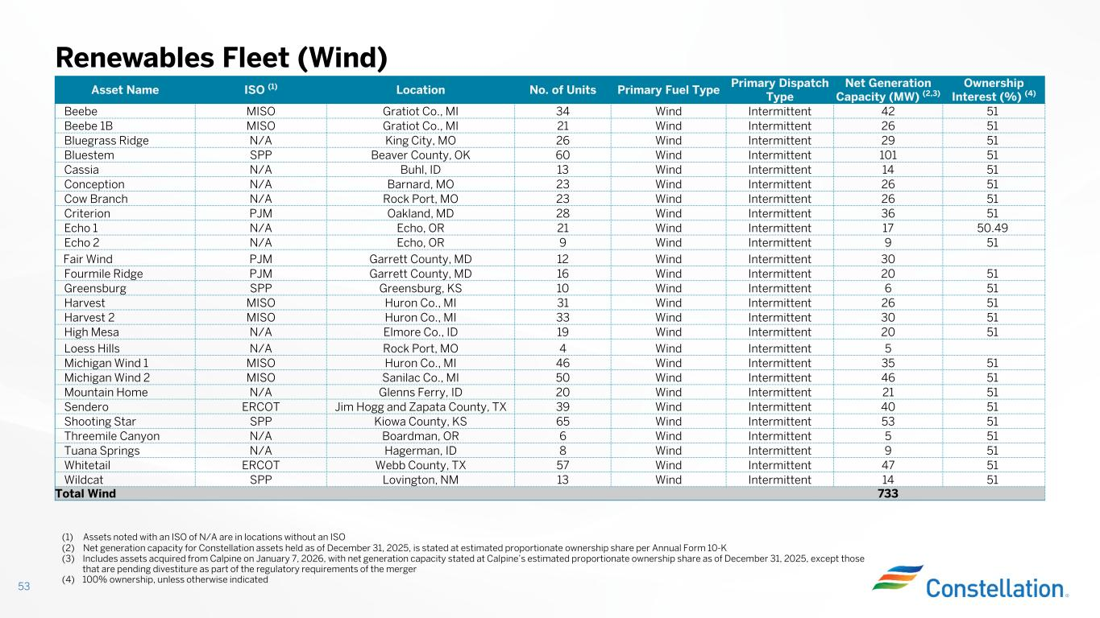
Renewables Fleet (Wind) 53 Ownership Interest (%) (4) Net Generation Capacity (MW) (2,3) Primary Dispatch Type Primary Fuel TypeNo. of UnitsLocationISO (1)Asset Name 5142IntermittentWind34Gratiot Co., MIMISOBeebe 5126IntermittentWind21Gratiot Co., MIMISOBeebe 1B 5129IntermittentWind26King City, MON/ABluegrass Ridge 51101IntermittentWind60Beaver County, OKSPPBluestem 5114IntermittentWind13Buhl, IDN/ACassia 5126IntermittentWind23Barnard, MON/AConception 5126IntermittentWind23Rock Port, MON/ACow Branch 5136IntermittentWind28Oakland, MDPJMCriterion 50.4917IntermittentWind21Echo, ORN/AEcho 1 519IntermittentWind9Echo, ORN/AEcho 2 30IntermittentWind12Garrett County, MDPJMFair Wind 5120IntermittentWind16Garrett County, MDPJMFourmile Ridge 516IntermittentWind10Greensburg, KSSPPGreensburg 5126IntermittentWind31Huron Co., MIMISOHarvest 5130IntermittentWind33Huron Co., MIMISOHarvest 2 5120IntermittentWind19Elmore Co., IDN/AHigh Mesa 5IntermittentWind4Rock Port, MON/ALoess Hills 5135IntermittentWind46Huron Co., MIMISOMichigan Wind 1 5146IntermittentWind50Sanilac Co., MIMISOMichigan Wind 2 5121IntermittentWind20Glenns Ferry, IDN/AMountain Home 5140IntermittentWind39Jim Hogg and Zapata County, TXERCOTSendero 5153IntermittentWind65Kiowa County, KSSPPShooting Star 515IntermittentWind6Boardman, ORN/AThreemile Canyon 519IntermittentWind8Hagerman, IDN/ATuana Springs 5147IntermittentWind57Webb County, TXERCOTWhitetail 5114IntermittentWind13Lovington, NMSPPWildcat 733Total Wind (1) Assets noted with an ISO of N/A are in locations without an ISO (2) Net generation capacity for Constellation assets held as of December 31, 2025, is stated at estimated proportionate ownership share per Annual Form 10-K (3) Includes assets acquired from Calpine on January 7, 2026, with net generation capacity stated at Calpine’s estimated proportionate ownership share as of December 31, 2025, except those that are pending divestiture as part of the regulatory requirements of the merger (4) 100% ownership, unless otherwise indicated

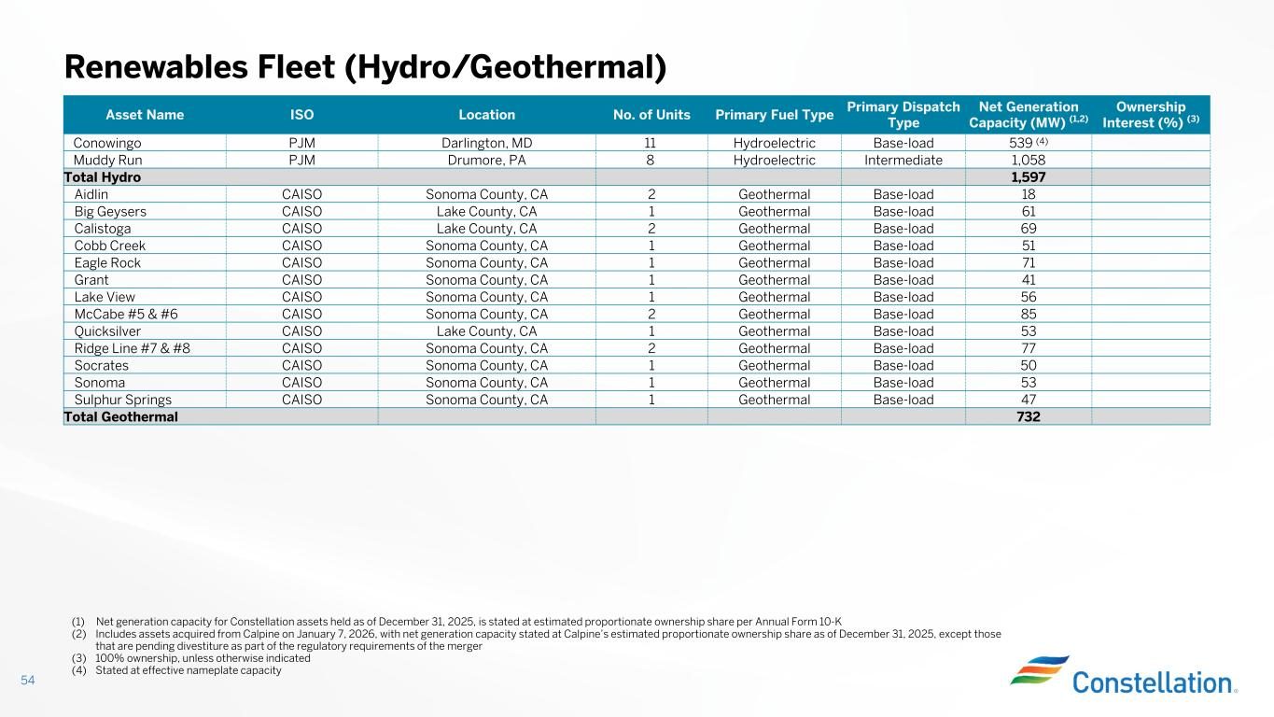
Renewables Fleet (Hydro/Geothermal) 54 Ownership Interest (%) (3) Net Generation Capacity (MW) (1,2) Primary Dispatch Type Primary Fuel TypeNo. of UnitsLocationISOAsset Name 539 (4)Base-loadHydroelectric11Darlington, MDPJMConowingo 1,058IntermediateHydroelectric8Drumore, PAPJMMuddy Run 1,597Total Hydro 18Base-loadGeothermal2Sonoma County, CACAISOAidlin 61Base-loadGeothermal1Lake County, CACAISOBig Geysers 69Base-loadGeothermal2Lake County, CACAISOCalistoga 51Base-loadGeothermal1Sonoma County, CACAISOCobb Creek 71Base-loadGeothermal1Sonoma County, CACAISOEagle Rock 41Base-loadGeothermal1Sonoma County, CACAISOGrant 56Base-loadGeothermal1Sonoma County, CACAISOLake View 85Base-loadGeothermal2Sonoma County, CACAISOMcCabe #5 & #6 53Base-loadGeothermal1Lake County, CACAISOQuicksilver 77Base-loadGeothermal2Sonoma County, CACAISORidge Line #7 & #8 50Base-loadGeothermal1Sonoma County, CACAISOSocrates 53Base-loadGeothermal1Sonoma County, CACAISOSonoma 47Base-loadGeothermal1Sonoma County, CACAISOSulphur Springs 732Total Geothermal (1) Net generation capacity for Constellation assets held as of December 31, 2025, is stated at estimated proportionate ownership share per Annual Form 10-K (2) Includes assets acquired from Calpine on January 7, 2026, with net generation capacity stated at Calpine’s estimated proportionate ownership share as of December 31, 2025, except those that are pending divestiture as part of the regulatory requirements of the merger (3) 100% ownership, unless otherwise indicated (4) Stated at effective nameplate capacity

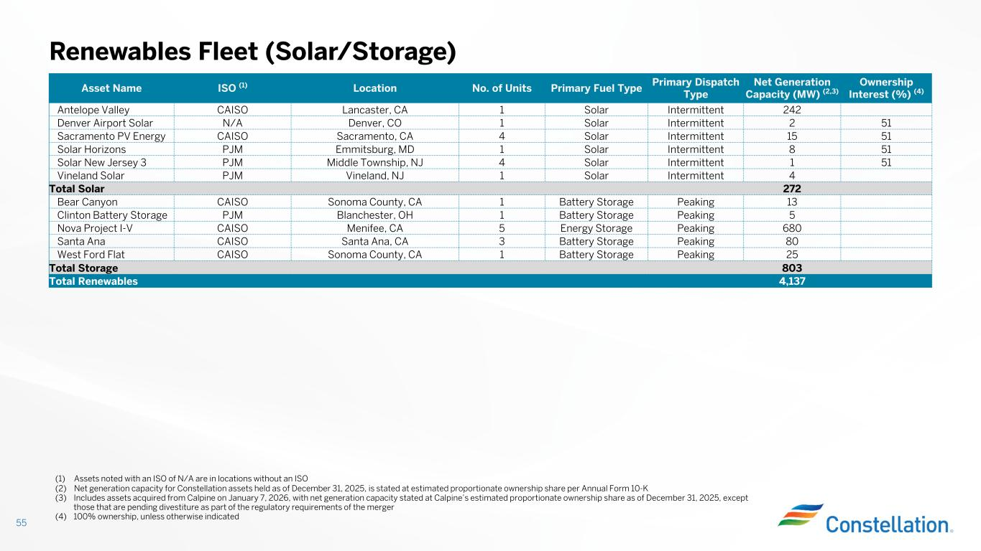
Renewables Fleet (Solar/Storage) 55 Ownership Interest (%) (4) Net Generation Capacity (MW) (2,3) Primary Dispatch Type Primary Fuel TypeNo. of UnitsLocationISO (1)Asset Name 242IntermittentSolar1Lancaster, CACAISOAntelope Valley 512IntermittentSolar1Denver, CON/ADenver Airport Solar 5115IntermittentSolar4Sacramento, CACAISOSacramento PV Energy 518IntermittentSolar1Emmitsburg, MDPJMSolar Horizons 511IntermittentSolar4Middle Township, NJPJMSolar New Jersey 3 4IntermittentSolar1Vineland, NJPJMVineland Solar 272Total Solar 13PeakingBattery Storage1Sonoma County, CACAISOBear Canyon 5PeakingBattery Storage1Blanchester, OHPJMClinton Battery Storage 680PeakingEnergy Storage5Menifee, CACAISONova Project I-V 80PeakingBattery Storage3Santa Ana, CACAISOSanta Ana 25PeakingBattery Storage1Sonoma County, CACAISOWest Ford Flat 803Total Storage 4,137Total Renewables (1) Assets noted with an ISO of N/A are in locations without an ISO (2) Net generation capacity for Constellation assets held as of December 31, 2025, is stated at estimated proportionate ownership share per Annual Form 10-K (3) Includes assets acquired from Calpine on January 7, 2026, with net generation capacity stated at Calpine’s estimated proportionate ownership share as of December 31, 2025, except those that are pending divestiture as part of the regulatory requirements of the merger (4) 100% ownership, unless otherwise indicated

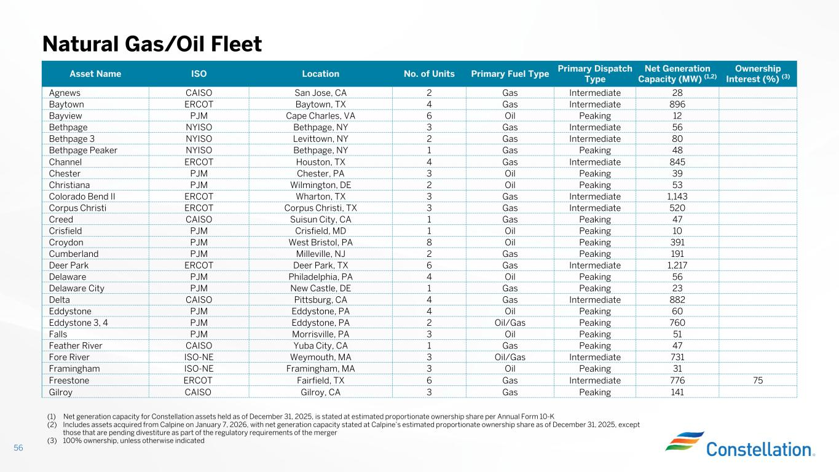
Natural Gas/Oil Fleet 56 Ownership Interest (%) (3) Net Generation Capacity (MW) (1,2) Primary Dispatch Type Primary Fuel TypeNo. of UnitsLocationISOAsset Name 28IntermediateGas2San Jose, CACAISOAgnews 896IntermediateGas4Baytown, TXERCOTBaytown 12PeakingOil6Cape Charles, VAPJMBayview 56IntermediateGas3Bethpage, NYNYISOBethpage 80IntermediateGas2Levittown, NYNYISOBethpage 3 48PeakingGas1Bethpage, NYNYISOBethpage Peaker 845IntermediateGas4Houston, TXERCOTChannel 39PeakingOil3Chester, PAPJMChester 53PeakingOil2Wilmington, DEPJMChristiana 1,143IntermediateGas3Wharton, TXERCOTColorado Bend II 520IntermediateGas3Corpus Christi, TXERCOTCorpus Christi 47PeakingGas1Suisun City, CACAISOCreed 10PeakingOil1Crisfield, MDPJMCrisfield 391PeakingOil8West Bristol, PAPJMCroydon 191PeakingGas2Milleville, NJPJMCumberland 1,217IntermediateGas6Deer Park, TXERCOTDeer Park 56PeakingOil4Philadelphia, PAPJMDelaware 23PeakingGas1New Castle, DEPJMDelaware City 882IntermediateGas4Pittsburg, CACAISODelta 60PeakingOil4Eddystone, PAPJMEddystone 760PeakingOil/Gas2Eddystone, PAPJMEddystone 3, 4 51PeakingOil3Morrisville, PAPJMFalls 47PeakingGas1Yuba City, CACAISOFeather River 731IntermediateOil/Gas3Weymouth, MAISO-NEFore River 31PeakingOil3Framingham, MAISO-NEFramingham 75776IntermediateGas6Fairfield, TXERCOTFreestone 141PeakingGas3Gilroy, CACAISOGilroy (1) Net generation capacity for Constellation assets held as of December 31, 2025, is stated at estimated proportionate ownership share per Annual Form 10-K (2) Includes assets acquired from Calpine on January 7, 2026, with net generation capacity stated at Calpine’s estimated proportionate ownership share as of December 31, 2025, except those that are pending divestiture as part of the regulatory requirements of the merger (3) 100% ownership, unless otherwise indicated

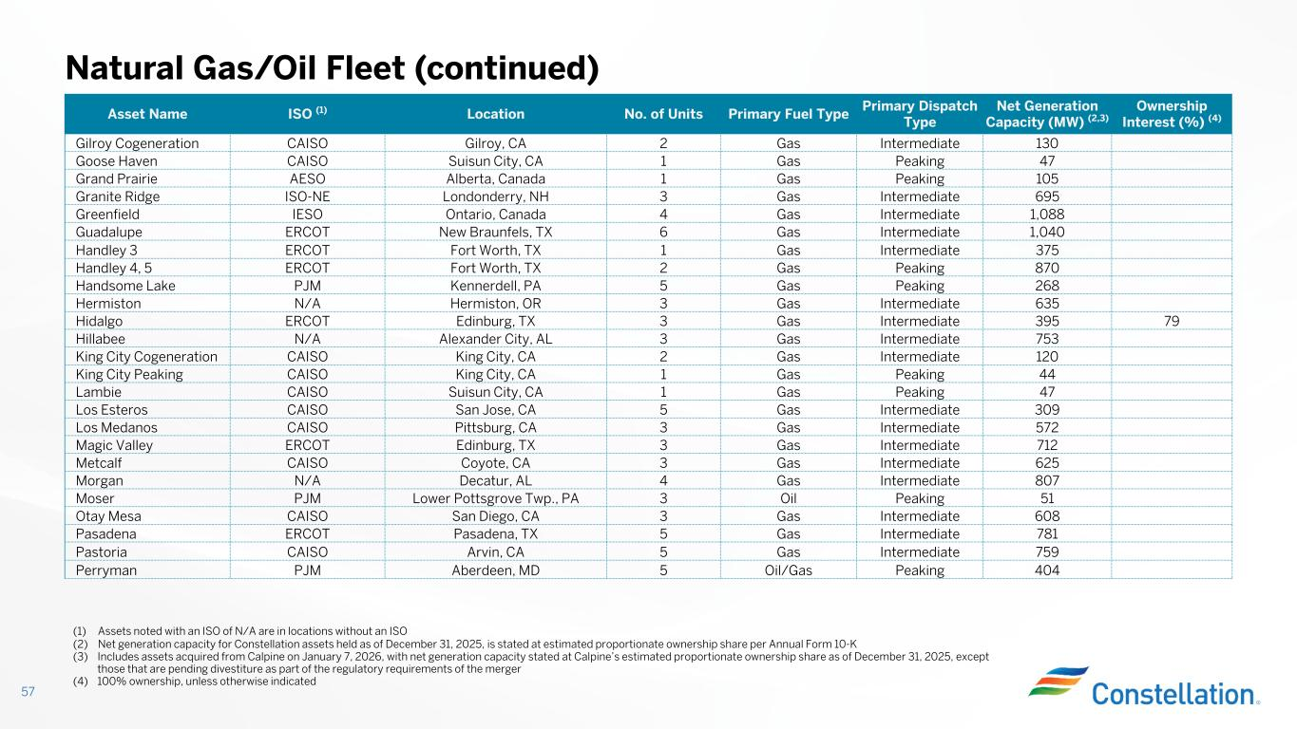
Natural Gas/Oil Fleet (continued) 57 Ownership Interest (%) (4) Net Generation Capacity (MW) (2,3) Primary Dispatch Type Primary Fuel TypeNo. of UnitsLocationISO (1)Asset Name 130IntermediateGas2Gilroy, CACAISOGilroy Cogeneration 47PeakingGas1Suisun City, CACAISOGoose Haven 105PeakingGas1Alberta, CanadaAESOGrand Prairie 695IntermediateGas3Londonderry, NHISO-NEGranite Ridge 1,088IntermediateGas4Ontario, CanadaIESOGreenfield 1,040IntermediateGas6New Braunfels, TXERCOTGuadalupe 375IntermediateGas1Fort Worth, TXERCOTHandley 3 870PeakingGas2Fort Worth, TXERCOTHandley 4, 5 268PeakingGas5Kennerdell, PAPJMHandsome Lake 635IntermediateGas3Hermiston, ORN/AHermiston 79395IntermediateGas3Edinburg, TXERCOTHidalgo 753IntermediateGas3Alexander City, ALN/AHillabee 120IntermediateGas2King City, CACAISOKing City Cogeneration 44PeakingGas1King City, CACAISOKing City Peaking 47PeakingGas1Suisun City, CACAISOLambie 309IntermediateGas5San Jose, CACAISOLos Esteros 572IntermediateGas3Pittsburg, CACAISOLos Medanos 712IntermediateGas3Edinburg, TXERCOTMagic Valley 625IntermediateGas3Coyote, CACAISOMetcalf 807IntermediateGas4Decatur, ALN/AMorgan 51PeakingOil3Lower Pottsgrove Twp., PAPJMMoser 608IntermediateGas3San Diego, CACAISOOtay Mesa 781IntermediateGas5Pasadena, TXERCOTPasadena 759IntermediateGas5Arvin, CACAISOPastoria 404PeakingOil/Gas5Aberdeen, MDPJMPerryman (1) Assets noted with an ISO of N/A are in locations without an ISO (2) Net generation capacity for Constellation assets held as of December 31, 2025, is stated at estimated proportionate ownership share per Annual Form 10-K (3) Includes assets acquired from Calpine on January 7, 2026, with net generation capacity stated at Calpine’s estimated proportionate ownership share as of December 31, 2025, except those that are pending divestiture as part of the regulatory requirements of the merger (4) 100% ownership, unless otherwise indicated

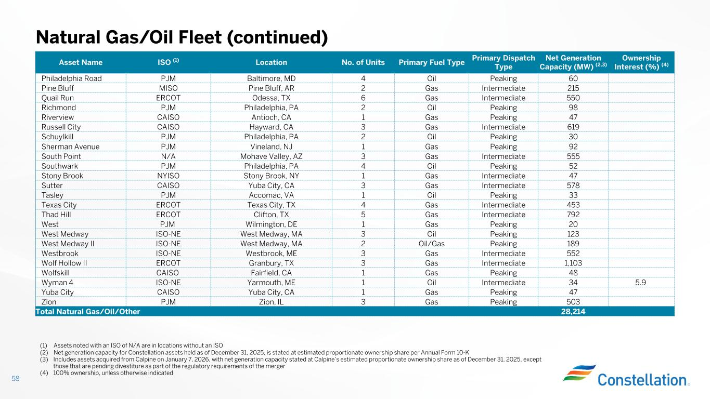
Natural Gas/Oil Fleet (continued) 58 Ownership Interest (%) (4) Net Generation Capacity (MW) (2,3) Primary Dispatch Type Primary Fuel TypeNo. of UnitsLocationISO (1)Asset Name 60PeakingOil4Baltimore, MDPJMPhiladelphia Road 215IntermediateGas2Pine Bluff, ARMISOPine Bluff 550IntermediateGas6Odessa, TXERCOTQuail Run 98PeakingOil2Philadelphia, PAPJMRichmond 47PeakingGas1Antioch, CACAISORiverview 619IntermediateGas3Hayward, CACAISORussell City 30PeakingOil2Philadelphia, PAPJMSchuylkill 92PeakingGas1Vineland, NJPJMSherman Avenue 555IntermediateGas3Mohave Valley, AZN/ASouth Point 52PeakingOil4Philadelphia, PAPJMSouthwark 47IntermediateGas1Stony Brook, NYNYISOStony Brook 578IntermediateGas3Yuba City, CACAISOSutter 33PeakingOil1Accomac, VAPJMTasley 453IntermediateGas4Texas City, TXERCOTTexas City 792IntermediateGas5Clifton, TXERCOTThad Hill 20PeakingGas1Wilmington, DEPJMWest 123PeakingOil3West Medway, MAISO-NEWest Medway 189PeakingOil/Gas2West Medway, MAISO-NEWest Medway II 552IntermediateGas3Westbrook, MEISO-NEWestbrook 1,103IntermediateGas3Granbury, TXERCOTWolf Hollow II 48PeakingGas1Fairfield, CACAISOWolfskill 5.934IntermediateOil1Yarmouth, MEISO-NEWyman 4 47PeakingGas1Yuba City, CACAISOYuba City 503PeakingGas3Zion, ILPJMZion 28,214Total Natural Gas/Oil/Other (1) Assets noted with an ISO of N/A are in locations without an ISO (2) Net generation capacity for Constellation assets held as of December 31, 2025, is stated at estimated proportionate ownership share per Annual Form 10-K (3) Includes assets acquired from Calpine on January 7, 2026, with net generation capacity stated at Calpine’s estimated proportionate ownership share as of December 31, 2025, except those that are pending divestiture as part of the regulatory requirements of the merger (4) 100% ownership, unless otherwise indicated

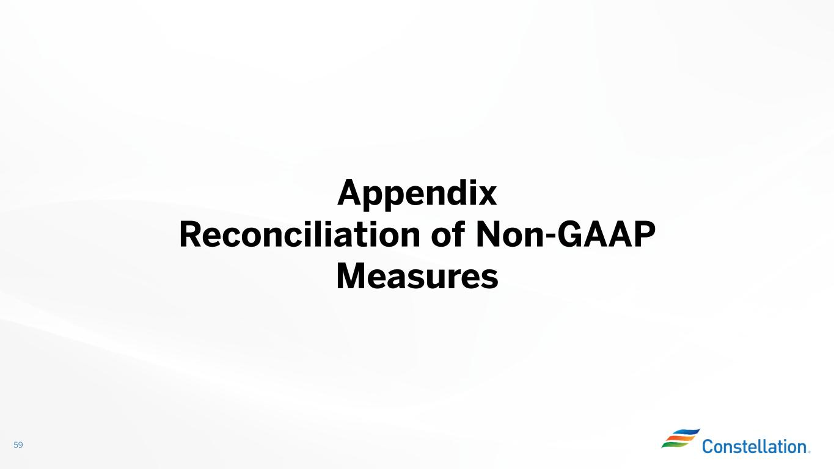
59 Appendix Reconciliation of Non-GAAP Measures

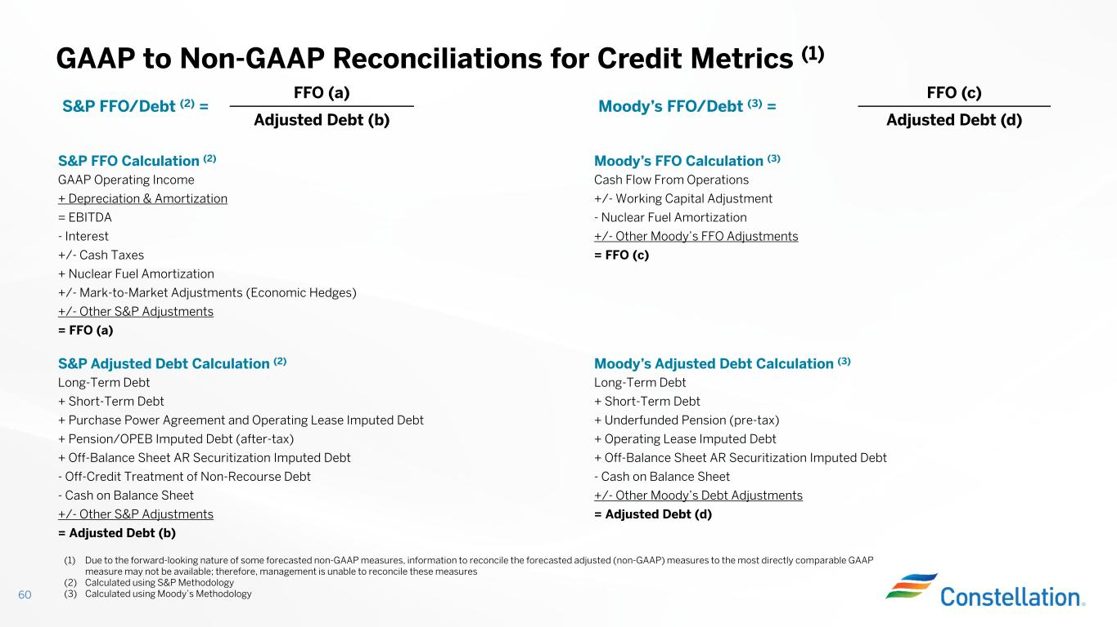
FFO (c) Moody’s FFO/Debt (3) = FFO (a) S&P FFO/Debt (2) = Adjusted Debt (d)Adjusted Debt (b) Moody’s FFO Calculation (3)S&P FFO Calculation (2) Cash Flow From OperationsGAAP Operating Income +/- Working Capital Adjustment+ Depreciation & Amortization - Nuclear Fuel Amortization= EBITDA +/- Other Moody’s FFO Adjustments- Interest = FFO (c) +/- Cash Taxes + Nuclear Fuel Amortization +/- Mark-to-Market Adjustments (Economic Hedges) +/- Other S&P Adjustments = FFO (a) Moody’s Adjusted Debt Calculation (3)S&P Adjusted Debt Calculation (2) Long-Term DebtLong-Term Debt + Short-Term Debt+ Short-Term Debt + Underfunded Pension (pre-tax)+ Purchase Power Agreement and Operating Lease Imputed Debt + Operating Lease Imputed Debt+ Pension/OPEB Imputed Debt (after-tax) + Off-Balance Sheet AR Securitization Imputed Debt+ Off-Balance Sheet AR Securitization Imputed Debt - Cash on Balance Sheet- Off-Credit Treatment of Non-Recourse Debt +/- Other Moody’s Debt Adjustments- Cash on Balance Sheet = Adjusted Debt (d)+/- Other S&P Adjustments = Adjusted Debt (b) GAAP to Non-GAAP Reconciliations for Credit Metrics (1) 60 (1) Due to the forward-looking nature of some forecasted non-GAAP measures, information to reconcile the forecasted adjusted (non-GAAP) measures to the most directly comparable GAAP measure may not be available; therefore, management is unable to reconcile these measures (2) Calculated using S&P Methodology (3) Calculated using Moody’s Methodology

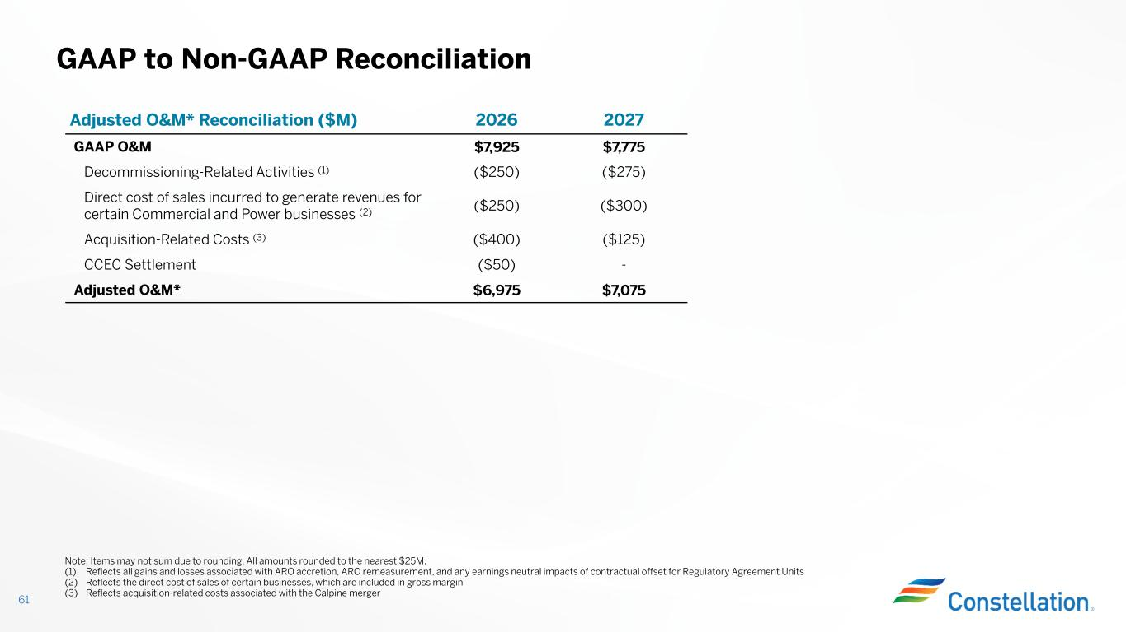
GAAP to Non-GAAP Reconciliation 61 20272026Adjusted O&M* Reconciliation ($M) $7,775$7,925GAAP O&M ($275)($250)Decommissioning-Related Activities (1) ($300)($250) Direct cost of sales incurred to generate revenues for certain Commercial and Power businesses (2) ($125)($400)Acquisition-Related Costs (3) -($50)CCEC Settlement $7,075$6,975Adjusted O&M* Note: Items may not sum due to rounding. All amounts rounded to the nearest $25M. (1) Reflects all gains and losses associated with ARO accretion, ARO remeasurement, and any earnings neutral impacts of contractual offset for Regulatory Agreement Units (2) Reflects the direct cost of sales of certain businesses, which are included in gross margin (3) Reflects acquisition-related costs associated with the Calpine merger

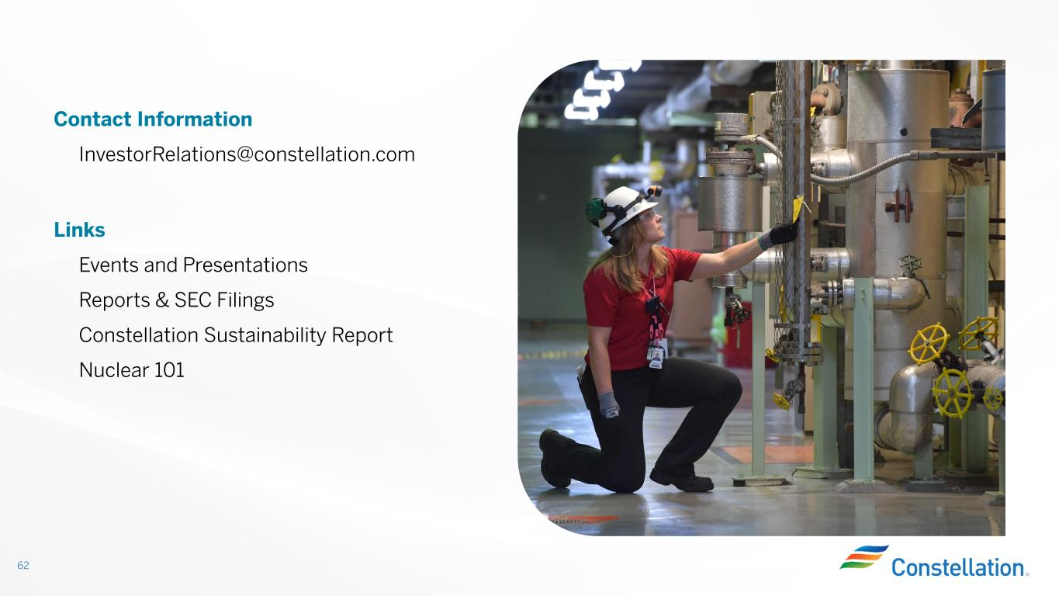
62 Contact Information InvestorRelations@constellation.com Links Events and Presentations Reports & SEC Filings Constellation Sustainability Report Nuclear 101

